# Sites that were included

NSABBS0003 Test Set: (Timestamp('2006-04-30 00:00:00'), Timestamp('2008-12-15 00:00:00')), Period: 81  
  
NSABBS0004 Test Set: (Timestamp('1987-09-09 00:00:00'), Timestamp('1992-11-25 00:00:00')), Period: 82  
  
NSABBS0005 Test Set: (Timestamp('2009-04-14 00:00:00'), Timestamp('2013-03-16 00:00:00')), Period: 77  
  
NSABBS0006 Test Set: (Timestamp('2003-08-28 00:00:00'), Timestamp('2006-02-17 00:00:00')), Period: 80  
  
NTAARP0001 Test Set: (Timestamp('2008-07-27 00:00:00'), Timestamp('2011-09-14 00:00:00')), Period: 82  
  
NTAARP0002 Test Set: (Timestamp('2011-08-29 00:00:00'), Timestamp('2014-10-16 00:00:00')), Period: 81  
  
NTAARP0003 Test Set: (Timestamp('2007-10-29 00:00:00'), Timestamp('2009-11-28 00:00:00')), Period: 106  
  
NTAARP0005 Test Set: (Timestamp('2005-09-06 00:00:00'), Timestamp('2008-05-09 00:00:00')), Period: 78  
  
NTADAC0002 Test Set: (Timestamp('2012-02-13 00:00:00'), Timestamp('2014-12-27 00:00:00')), Period: 81  
  
NTAGFU0003 Test Set: (Timestamp('2012-07-10 00:00:00'), Timestamp('2015-05-16 00:00:00')), Period: 92  
  
NTAGFU0018 Test Set: (Timestamp('2015-03-13 00:00:00'), Timestamp('2017-08-25 00:00:00')), Period: 90  
  
NTAGFU0030 Test Set: (Timestamp('2003-09-10 00:00:00'), Timestamp('2006-03-10 00:00:00')), Period: 80  
  
NTAGFU0033 Test Set: (Timestamp('2006-05-13 00:00:00'), Timestamp('2008-10-17 00:00:00')), Period: 77  
  
NTAGFU0034 Test Set: (Timestamp('1993-03-22 00:00:00'), Timestamp('1999-02-03 00:00:00')), Period: 81  
  
NTAGFU0036 Test Set: (Timestamp('2017-10-09 00:00:00'), Timestamp('2020-06-11 00:00:00')), Period: 156  
  
NTAGFU0038 Test Set: (Timestamp('2015-04-04 00:00:00'), Timestamp('2017-10-10 00:00:00')), Period: 152  
  
NTAMGD0001 Test Set: (Timestamp('1998-03-22 00:00:00'), Timestamp('2002-12-15 00:00:00')), Period: 166  
  
NTAPCK0003 Test Set: (Timestamp('1987-09-05 00:00:00'), Timestamp('1994-03-23 00:00:00')), Period: 134  
  
NTAPCK0005 Test Set: (Timestamp('1993-06-24 00:00:00'), Timestamp('1998-08-18 00:00:00')), Period: 146  
  
NTAPCK1010 Test Set: (Timestamp('1992-12-23 00:00:00'), Timestamp('1998-05-30 00:00:00')), Period: 78  
  
NTAPCK1012 Test Set: (Timestamp('2006-02-21 00:00:00'), Timestamp('2008-09-30 00:00:00')), Period: 81  
  
NTAPCK2013 Test Set: (Timestamp('1993-04-14 00:00:00'), Timestamp('1998-11-22 00:00:00')), Period: 82  
  
NTTDAB0001 Test Set: (Timestamp('1987-09-12 00:00:00'), Timestamp('1993-01-15 00:00:00')), Period: 83  
  
NTTPCK0001 Test Set: (Timestamp('1998-01-04 00:00:00'), Timestamp('2002-07-02 00:00:00')), Period: 146  
  
NTTSTU0001 Test Set: (Timestamp('1997-11-03 00:00:00'), Timestamp('2002-12-27 00:00:00')), Period: 92  
  
QDABBN0002 Test Set: (Timestamp('2008-09-16 00:00:00'), Timestamp('2012-01-07 00:00:00')), Period: 83  
  
QDABBS0003 Test Set: (Timestamp('1997-12-07 00:00:00'), Timestamp('2003-01-14 00:00:00')), Period: 82  
  
QDABBS0005 Test Set: (Timestamp('2019-11-26 00:00:00'), Timestamp('2022-12-21 00:00:00')), Period: 84  
  
QDABBS0009 Test Set: (Timestamp('1987-09-18 00:00:00'), Timestamp('1993-04-27 00:00:00')), Period: 79  
  
QDACYP0008 Test Set: (Timestamp('2016-12-07 00:00:00'), Timestamp('2019-10-21 00:00:00')), Period: 83  
  
QDACYP0012 Test Set: (Timestamp('2003-07-29 00:00:00'), Timestamp('2005-08-11 00:00:00')), Period: 61  
  
QDACYP0016 Test Set: (Timestamp('2009-09-23 00:00:00'), Timestamp('2013-04-11 00:00:00')), Period: 51  
  
QDACYP0020 Test Set: (Timestamp('2019-12-07 00:00:00'), Timestamp('2022-12-07 00:00:00')), Period: 70  
  
QDACYP0021 Test Set: (Timestamp('2011-04-30 00:00:00'), Timestamp('2014-09-12 00:00:00')), Period: 70  
  
QDACYP0024 Test Set: (Timestamp('1993-05-21 00:00:00'), Timestamp('1998-01-12 00:00:00')), Period: 92  
  
QDAEIU0006 Test Set: (Timestamp('2020-05-25 00:00:00'), Timestamp('2022-12-17 00:00:00')), Period: 152  
  
QDAEIU0007 Test Set: (Timestamp('2015-04-27 00:00:00'), Timestamp('2017-11-17 00:00:00')), Period: 148  
  
QDAGUP0002 Test Set: (Timestamp('2003-03-25 00:00:00'), Timestamp('2005-11-25 00:00:00')), Period: 89  
  
QDAGUP0003 Test Set: (Timestamp('2017-10-09 00:00:00'), Timestamp('2020-04-16 00:00:00')), Period: 90  
  
QDAGUP0004 Test Set: (Timestamp('2017-10-24 00:00:00'), Timestamp('2020-05-17 00:00:00')), Period: 93  
  
QDAGUP0005 Test Set: (Timestamp('2015-06-13 00:00:00'), Timestamp('2017-11-01 00:00:00')), Period: 92  
  
QDAGUP0006 Test Set: (Timestamp('2020-05-17 00:00:00'), Timestamp('2022-12-17 00:00:00')), Period: 92  
  
QDAGUP0021 Test Set: (Timestamp('1992-09-23 00:00:00'), Timestamp('1998-09-25 00:00:00')), Period: 155  
  
QDAGUP0027 Test Set: (Timestamp('2004-03-01 00:00:00'), Timestamp('2007-03-10 00:00:00')), Period: 87  
  
QDAGUP0028 Test Set: (Timestamp('1987-09-11 00:00:00'), Timestamp('1993-08-09 00:00:00')), Period: 94  
  
QDAMGD0025 Test Set: (Timestamp('2015-05-13 00:00:00'), Timestamp('2017-11-18 00:00:00')), Period: 92  
  
QDAMGD0026 Test Set: (Timestamp('1987-09-12 00:00:00'), Timestamp('1992-10-27 00:00:00')), Period: 92  
  
WAACEK0001 Test Set: (Timestamp('2019-12-22 00:00:00'), Timestamp('2022-12-06 00:00:00')), Period: 89  
  
WAADAL0004 Test Set: (Timestamp('2012-09-11 00:00:00'), Timestamp('2015-09-12 00:00:00')), Period: 87  
  
WAANOK0001 Test Set: (Timestamp('2018-06-26 00:00:00'), Timestamp('2020-08-18 00:00:00')), Period: 86  
  
WAANOK0002 Test Set: (Timestamp('2006-06-09 00:00:00'), Timestamp('2008-11-21 00:00:00')), Period: 87  
  
WAANOK0006 Test Set: (Timestamp('1998-10-17 00:00:00'), Timestamp('2003-10-07 00:00:00')), Period: 89

# Table: MSE of the Random Forest on each output

|  |  |  |  |  |
| --- | --- | --- | --- | --- |
|  | pv_filter | npv_filter | bs_filter | loss_mean |
| Train | 1.523 | 1.176 | 1.269 | 1.322 |
| Test | 23.835 | 20.317 | 23.05 | 22.4 |

# Permutation Importance

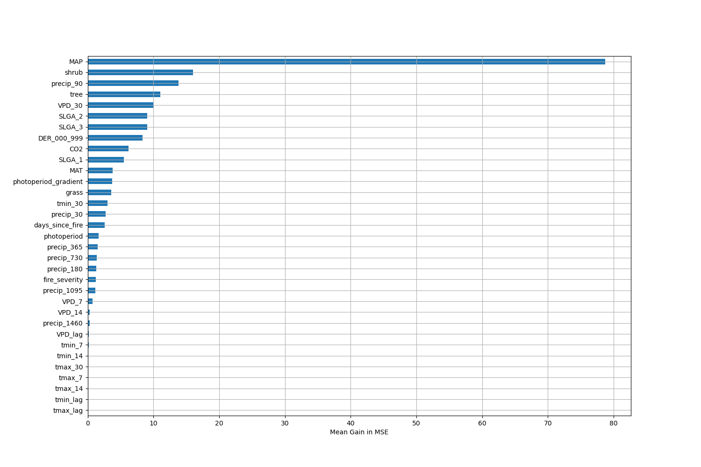

# Permutation Importance by Precip

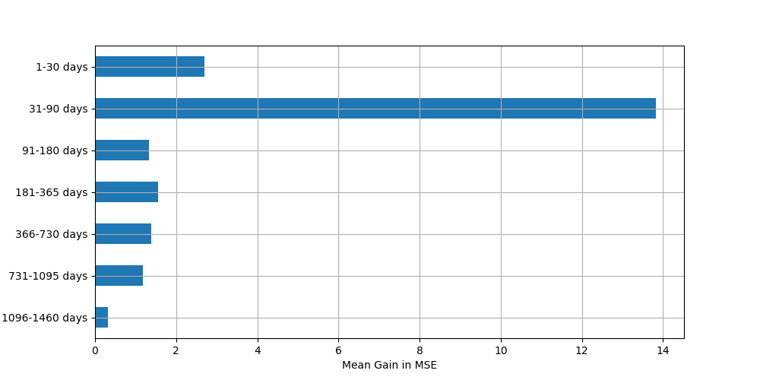

# ALE Importance

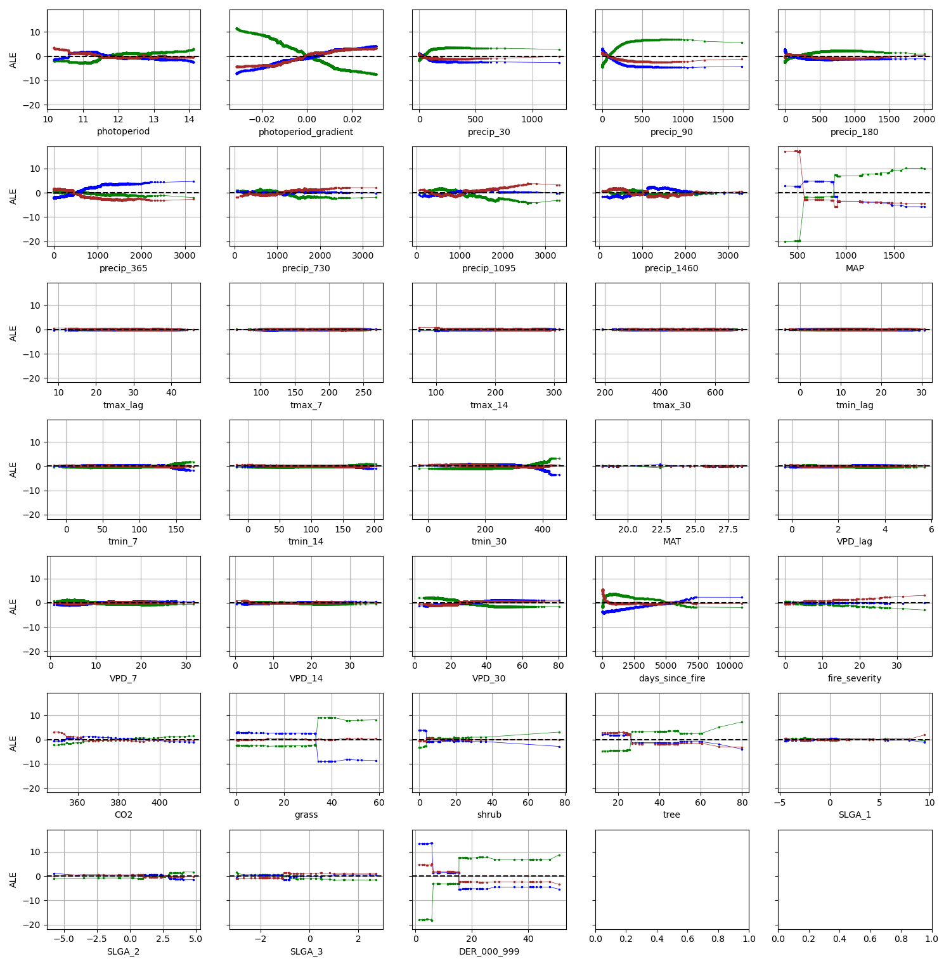

# NSABBS0003

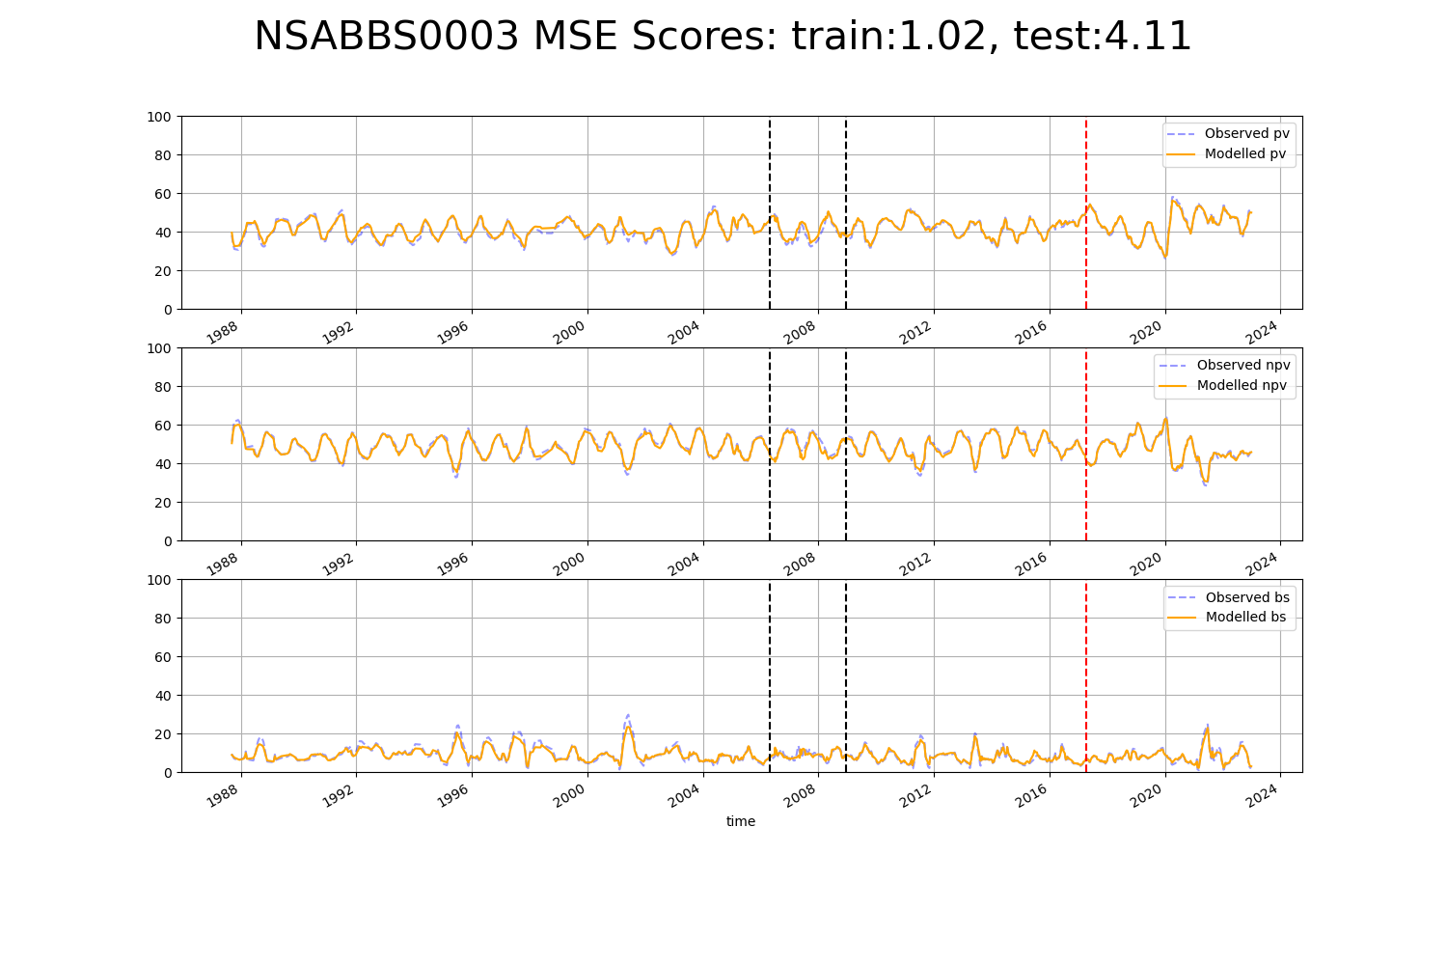

# NSABBS0004

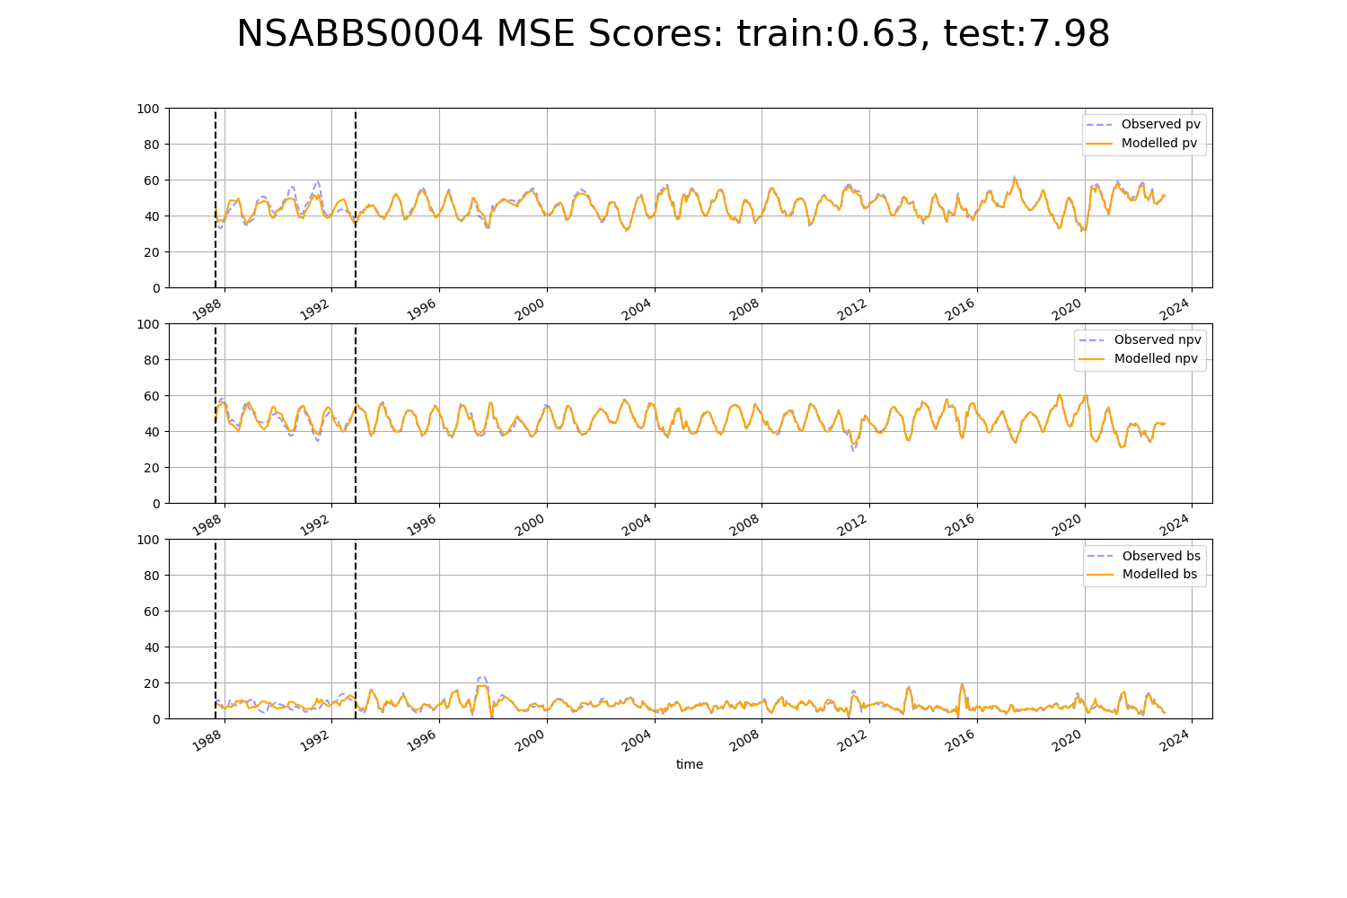

# NSABBS0005

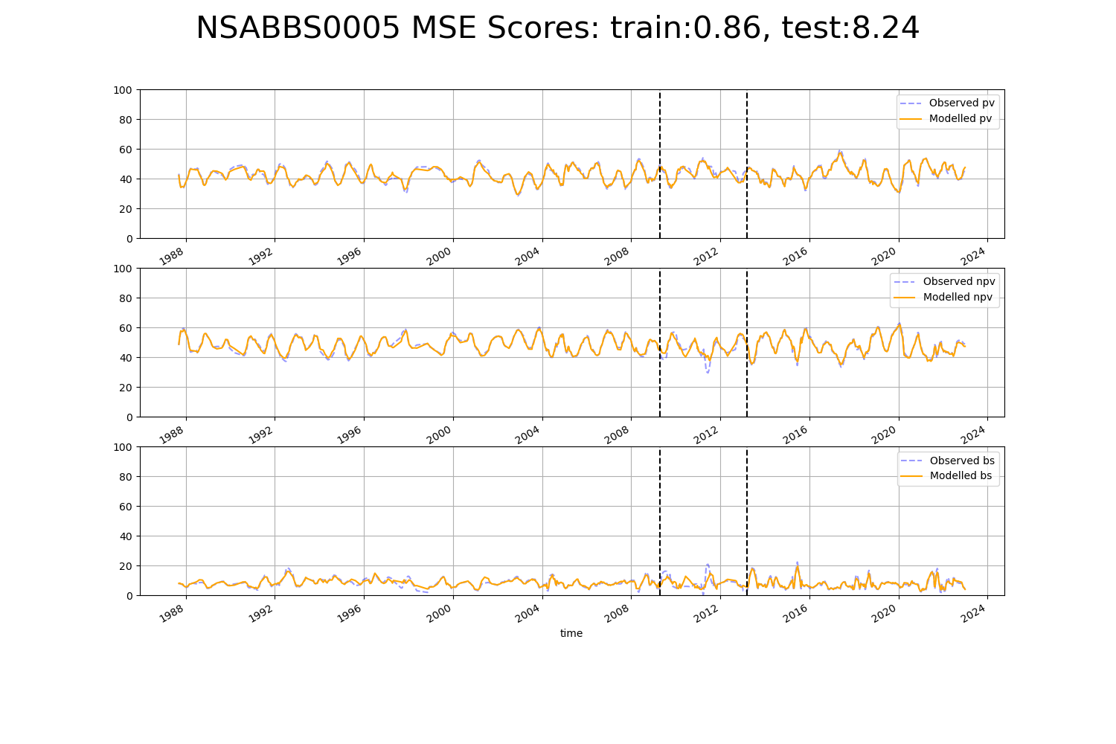

# NSABBS0006

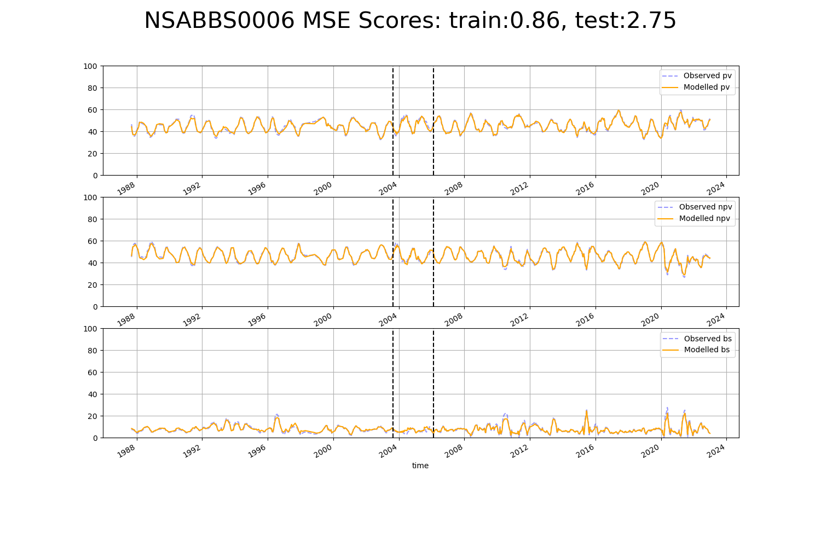

# NTAARP0001

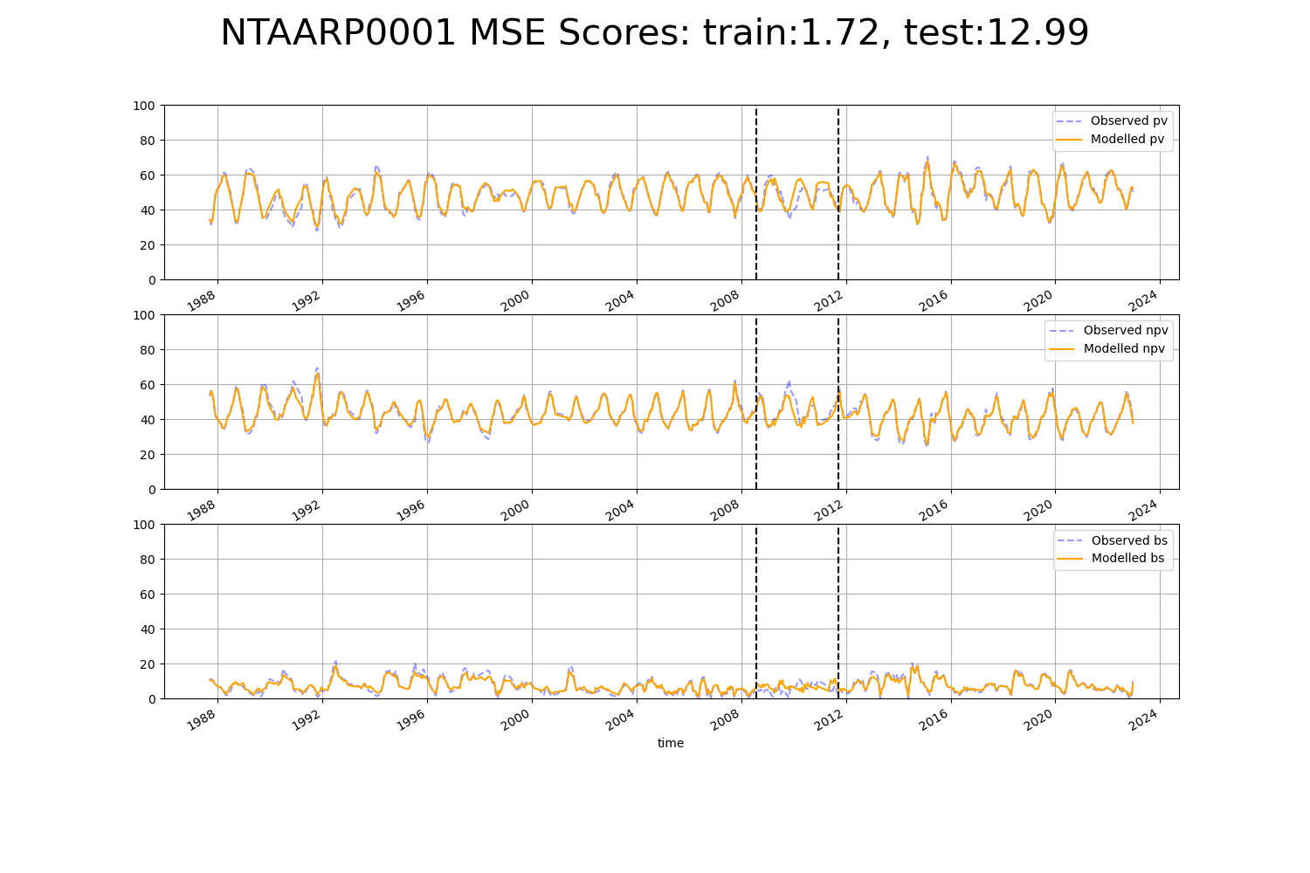

# NTAARP0002

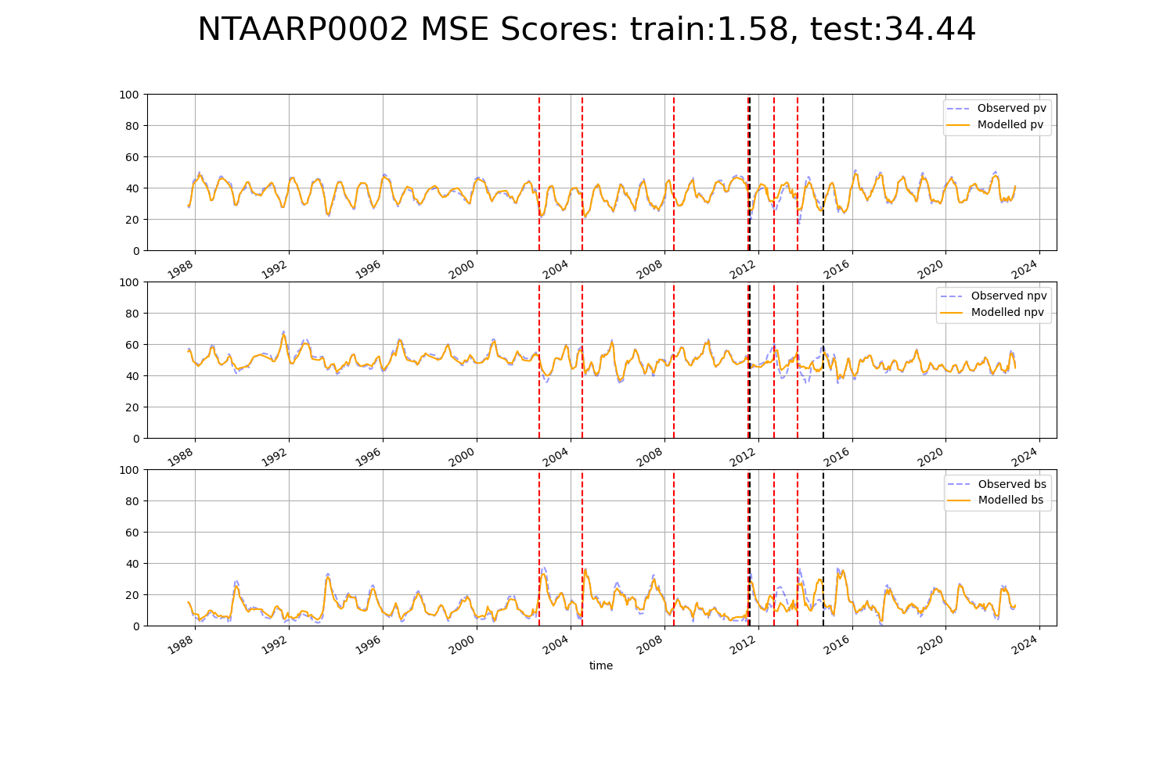

# NTAARP0003

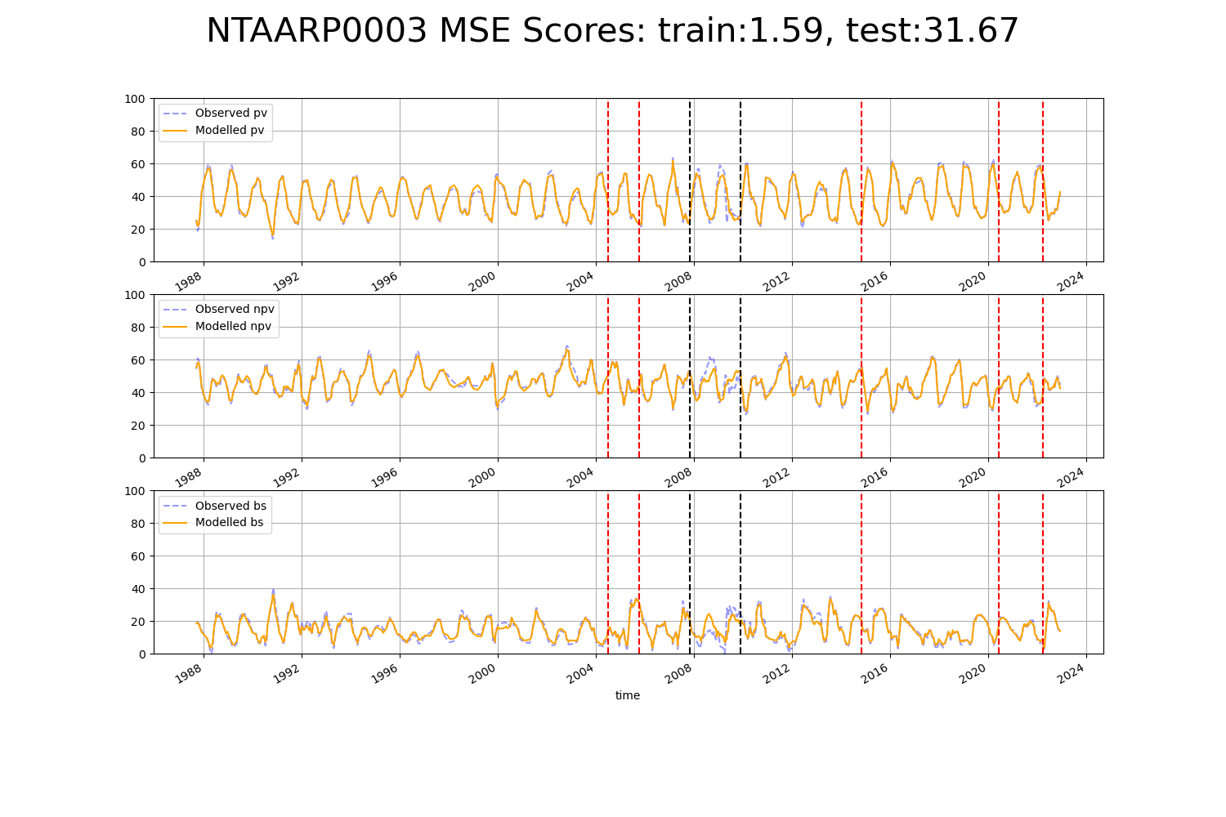

# NTAARP0005

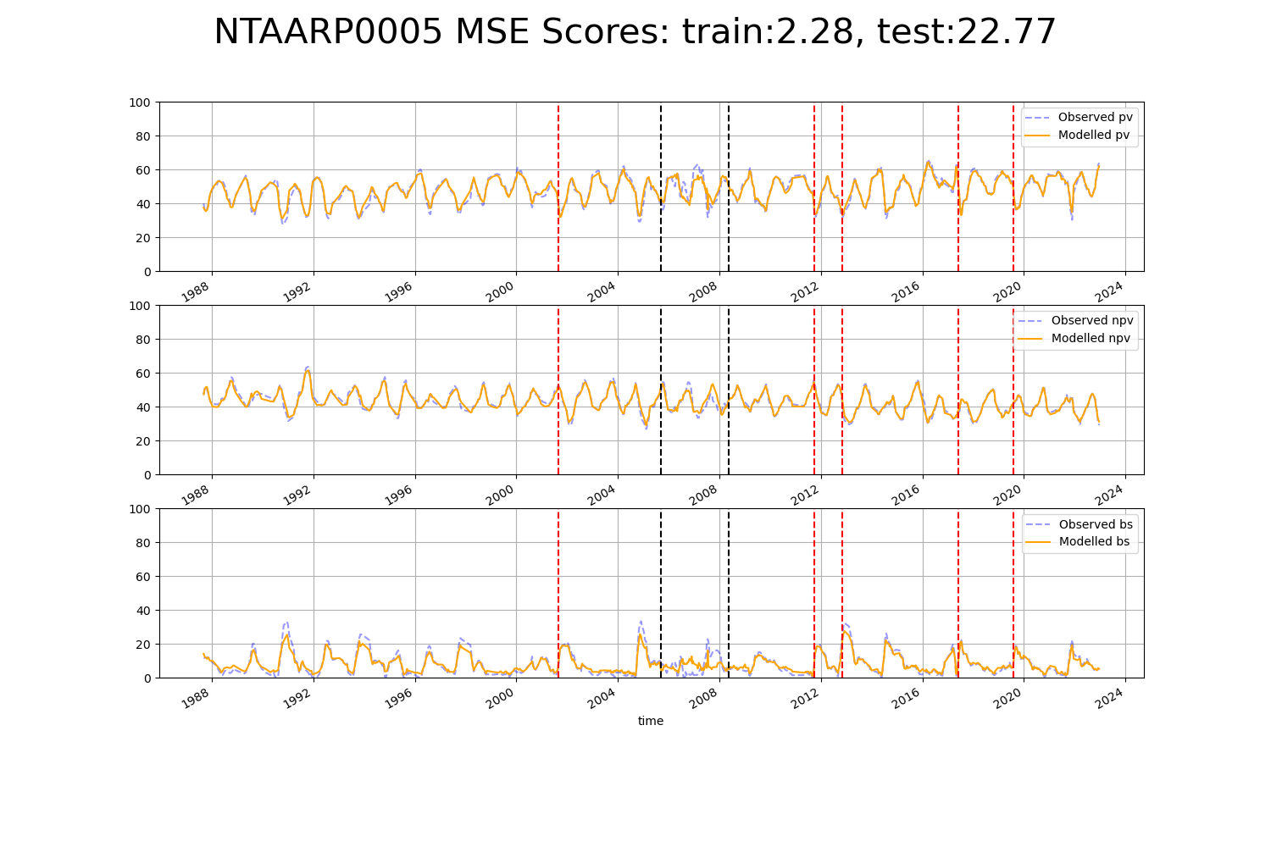

# NTADAC0002

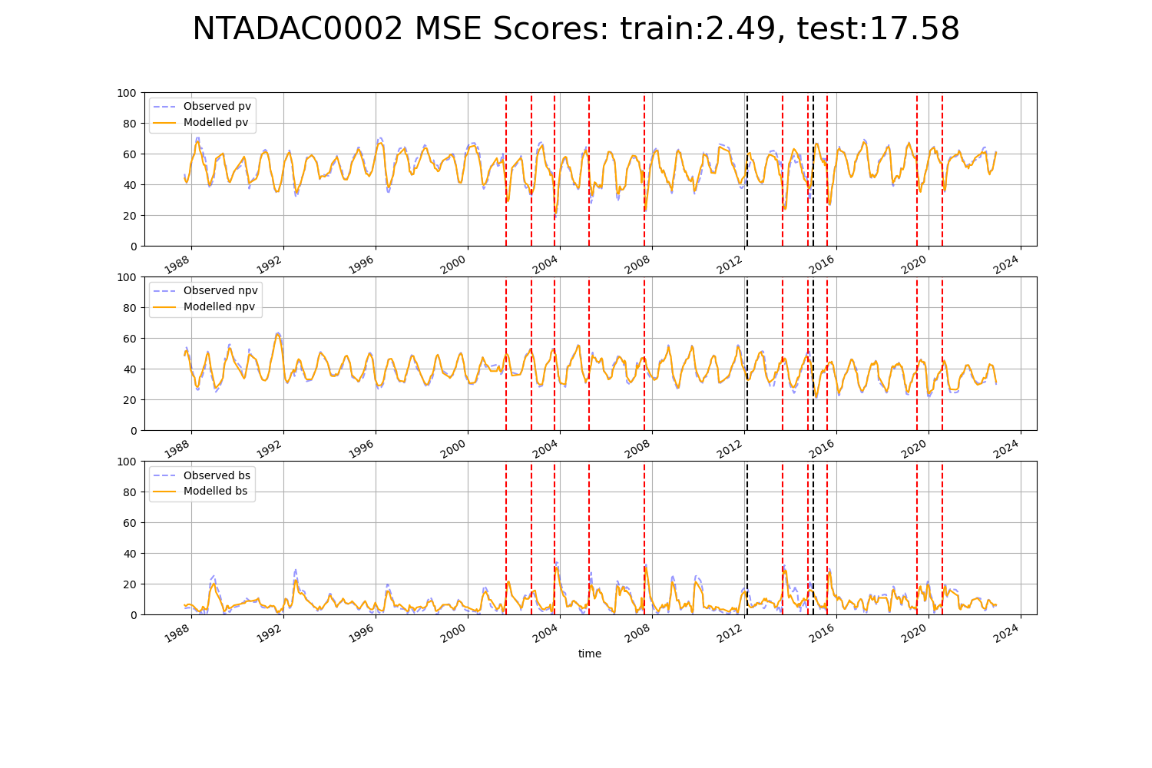

# NTAGFU0003

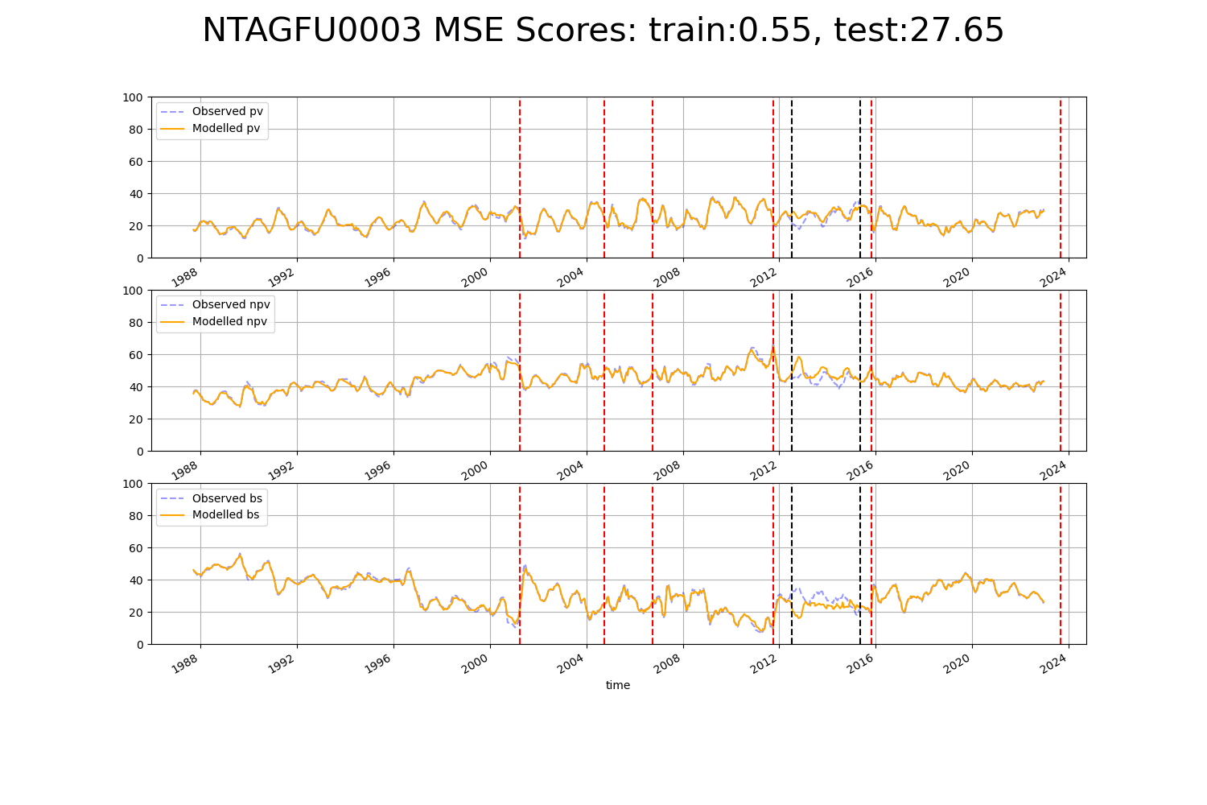

# NTAGFU0018

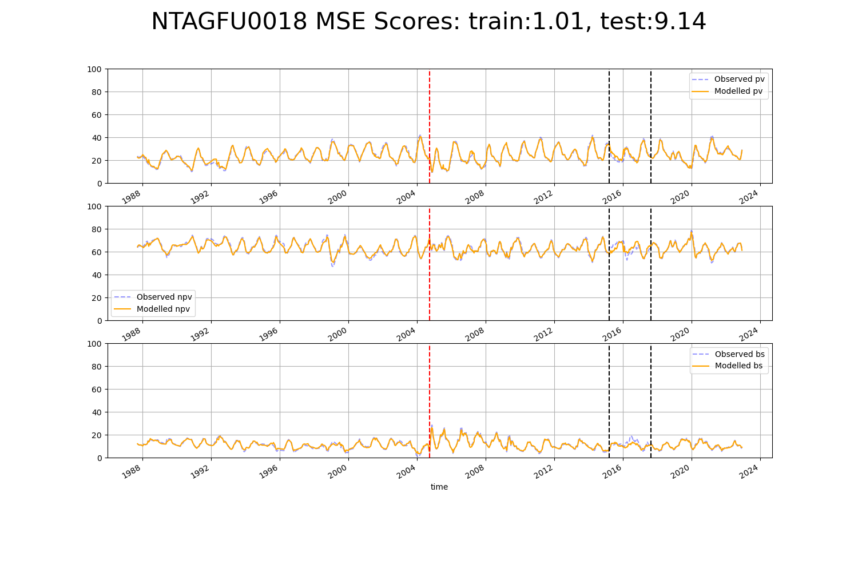

# NTAGFU0030

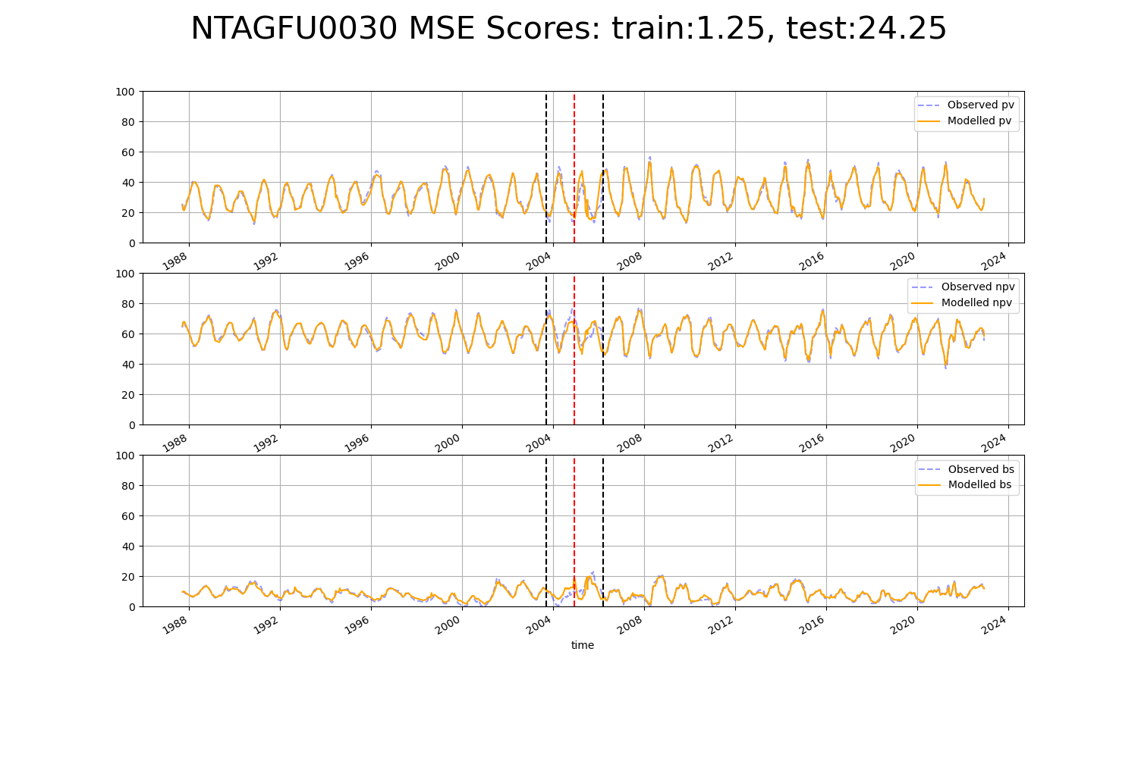

# NTAGFU0033

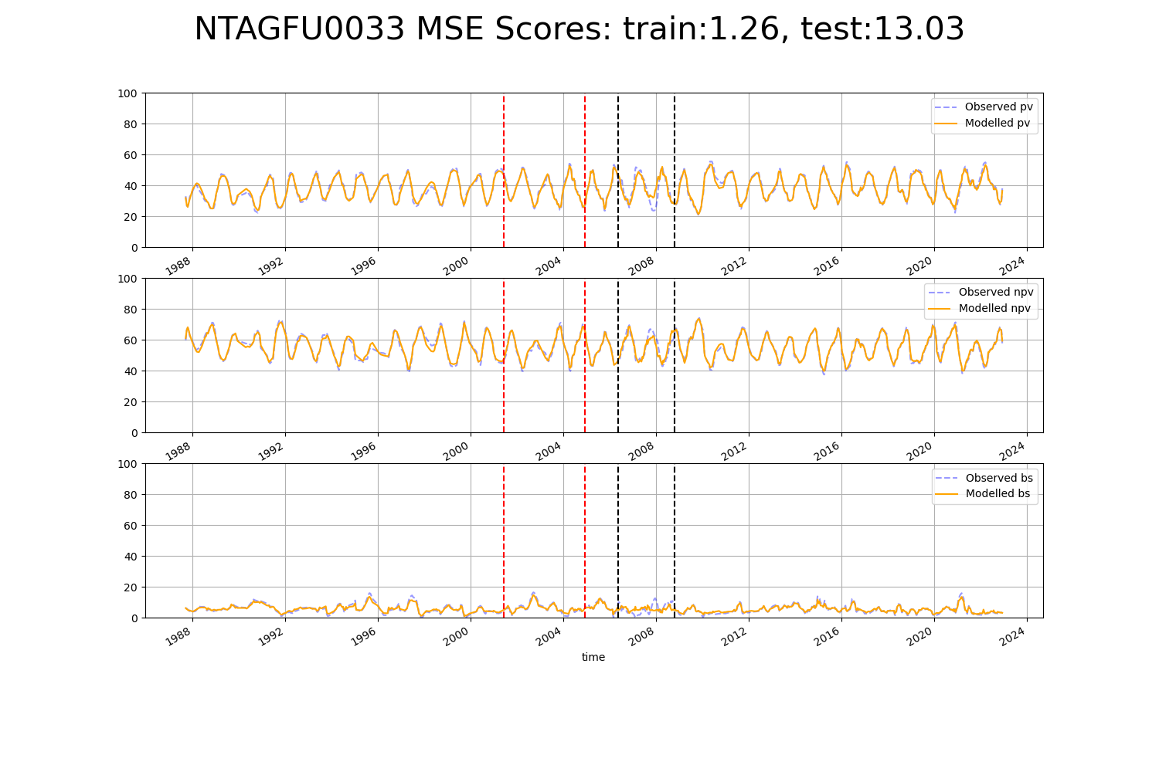

# NTAGFU0034

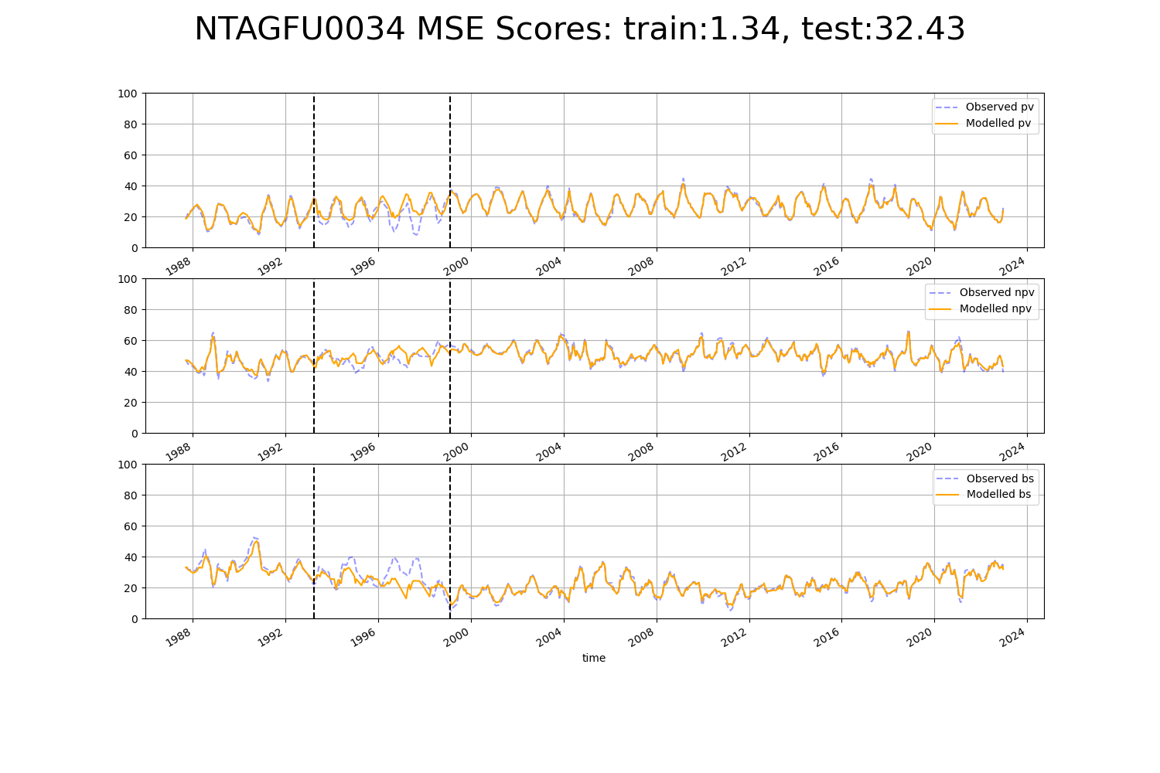

# NTAGFU0036

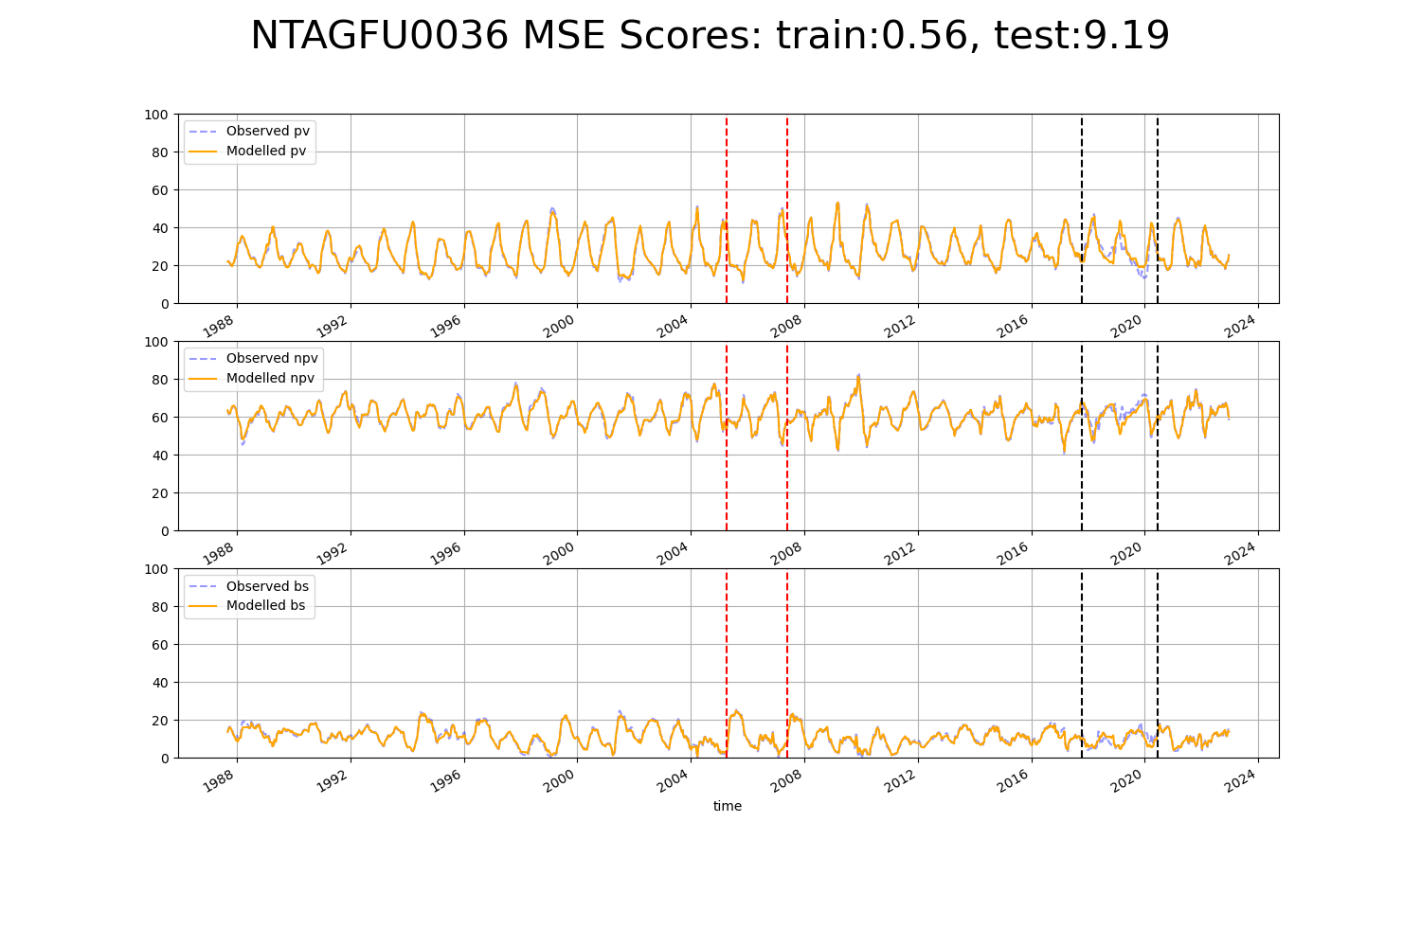

# NTAGFU0038

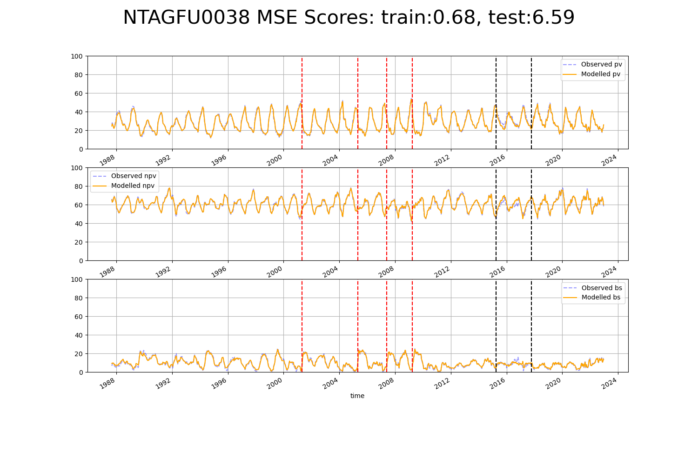

# NTAMGD0001

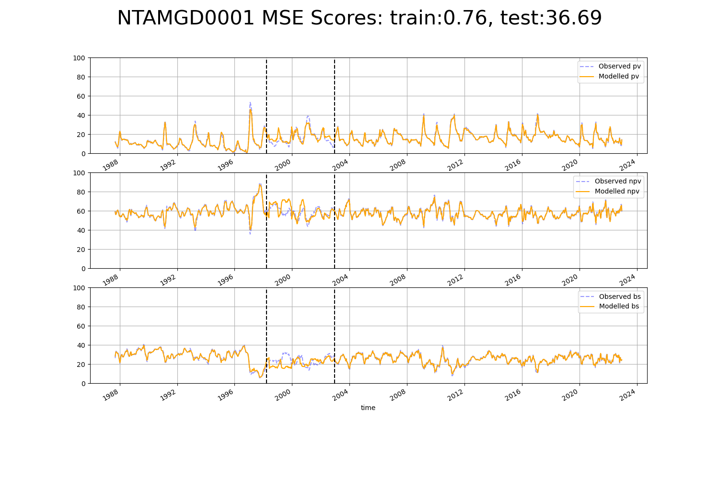

# NTAPCK0003

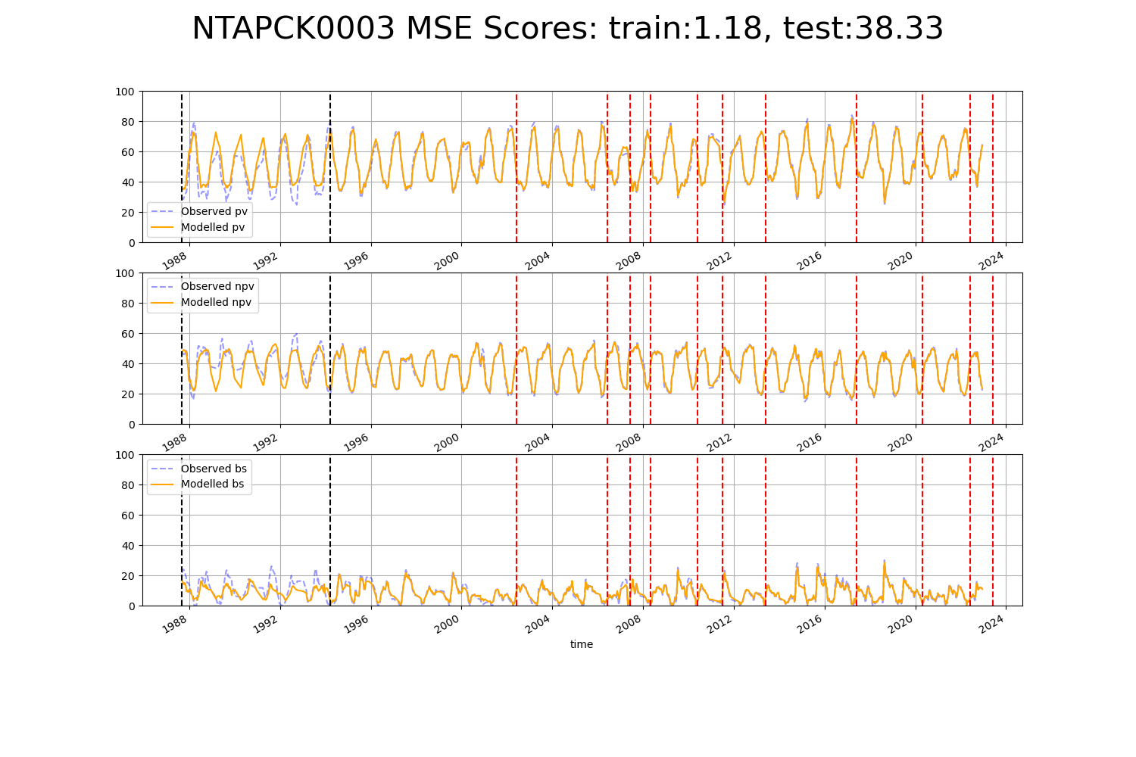

# NTAPCK0005

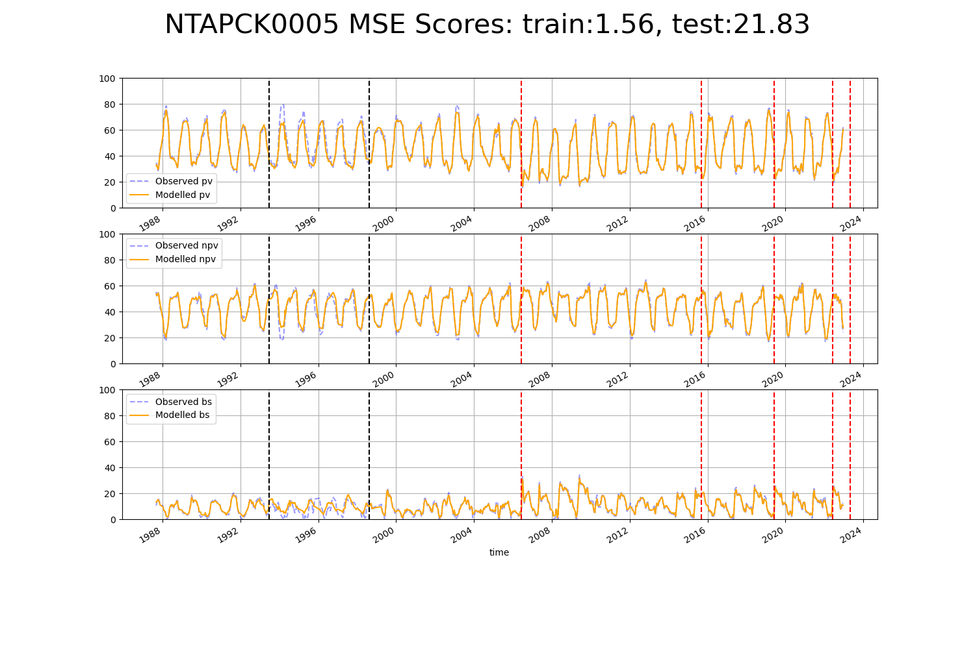

# NTAPCK1010

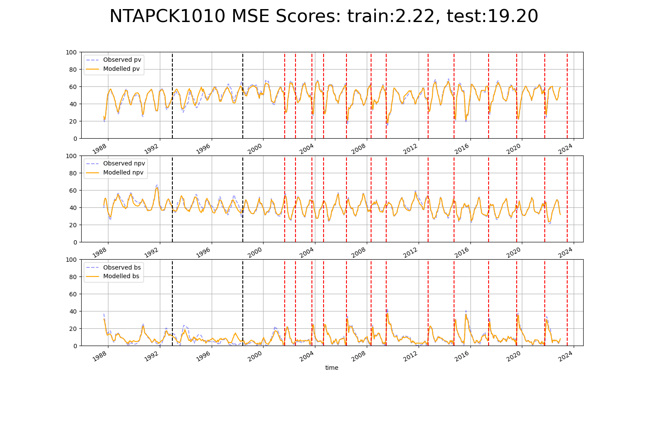

# NTAPCK1012

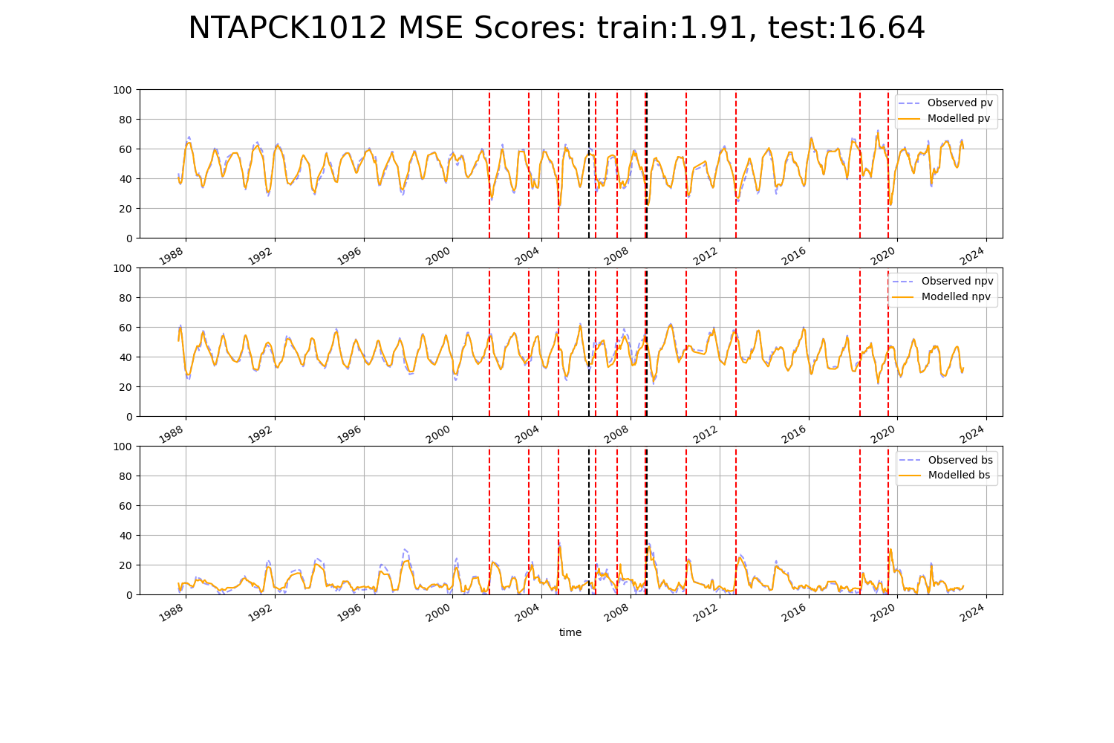

# NTAPCK2013

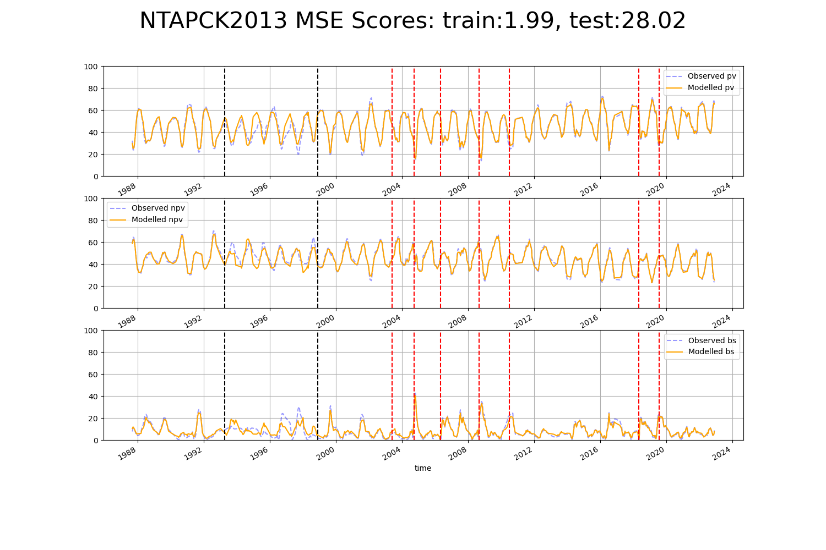

# NTTDAB0001

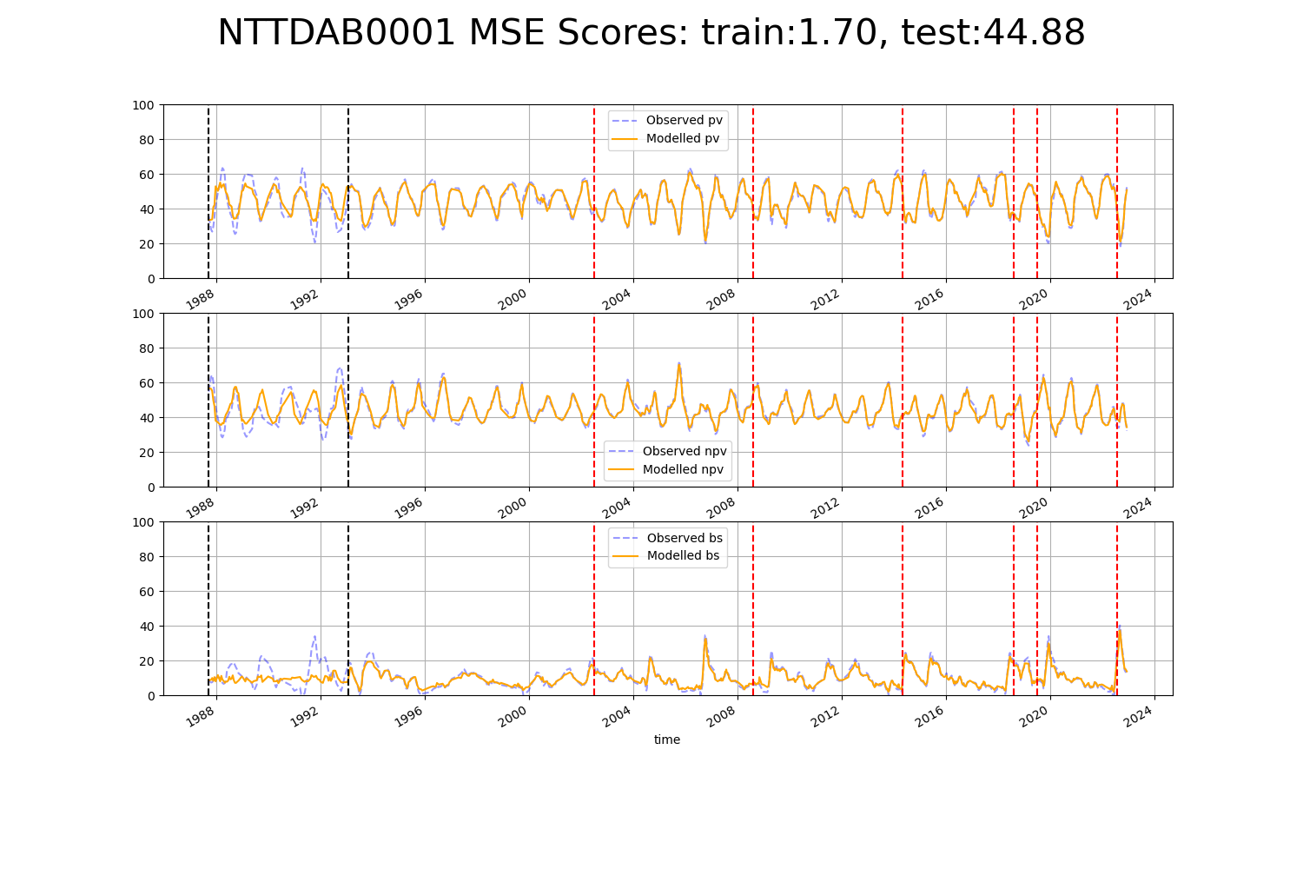

# NTTPCK0001

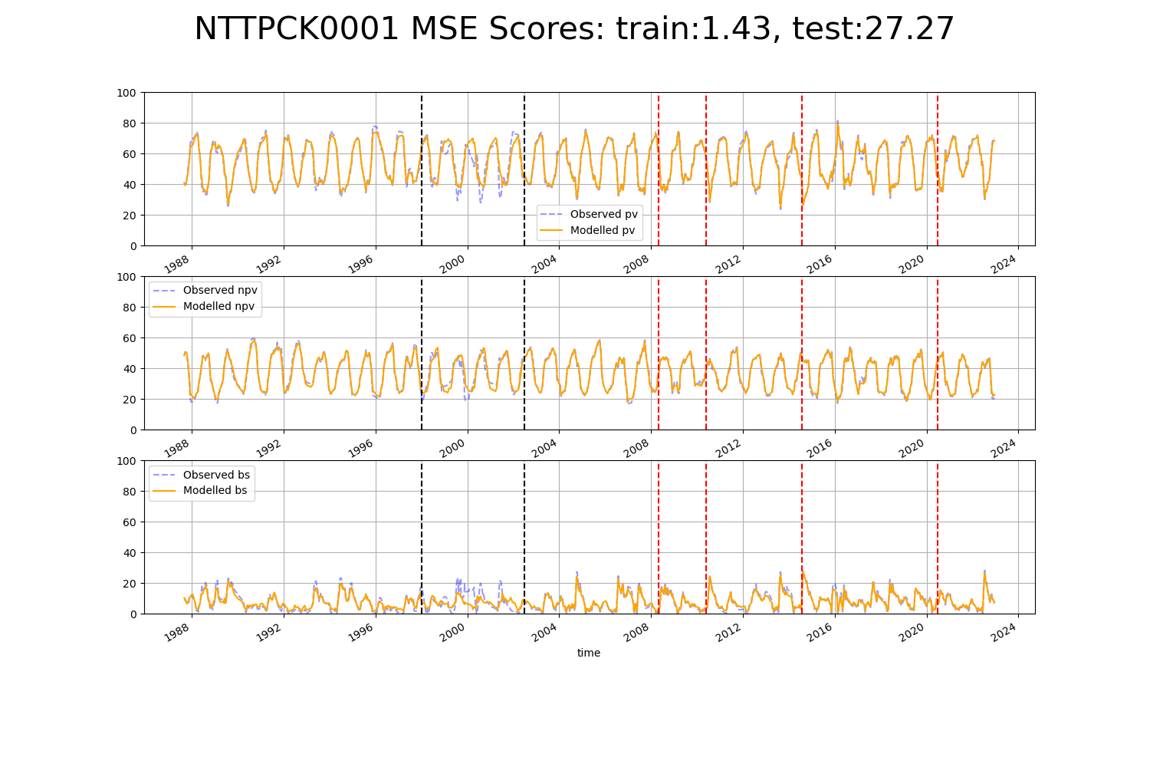

# NTTSTU0001

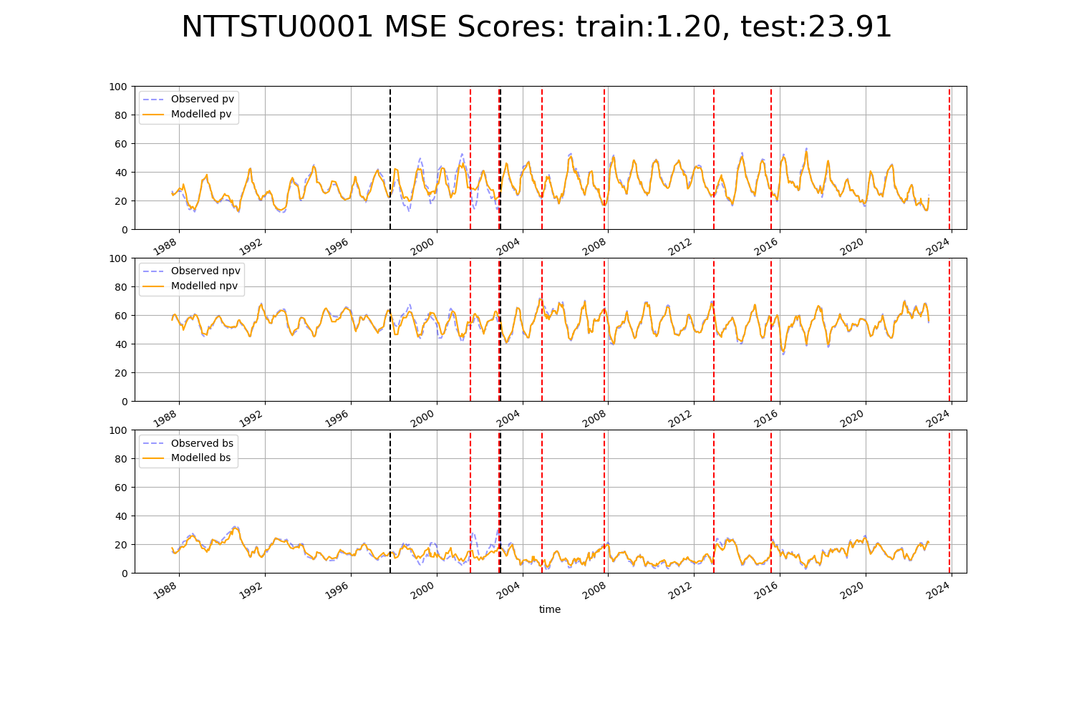

# QDABBN0002

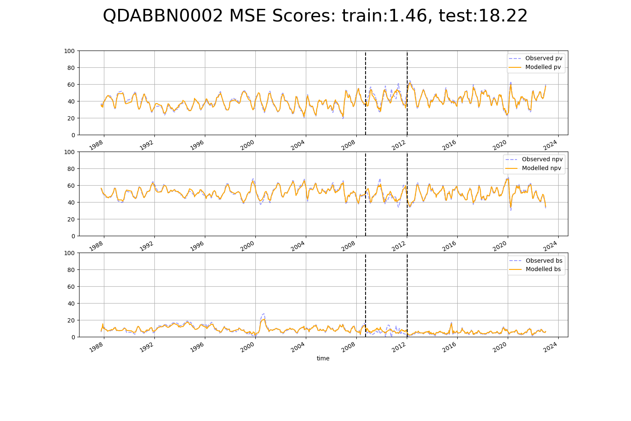

# QDABBS0003

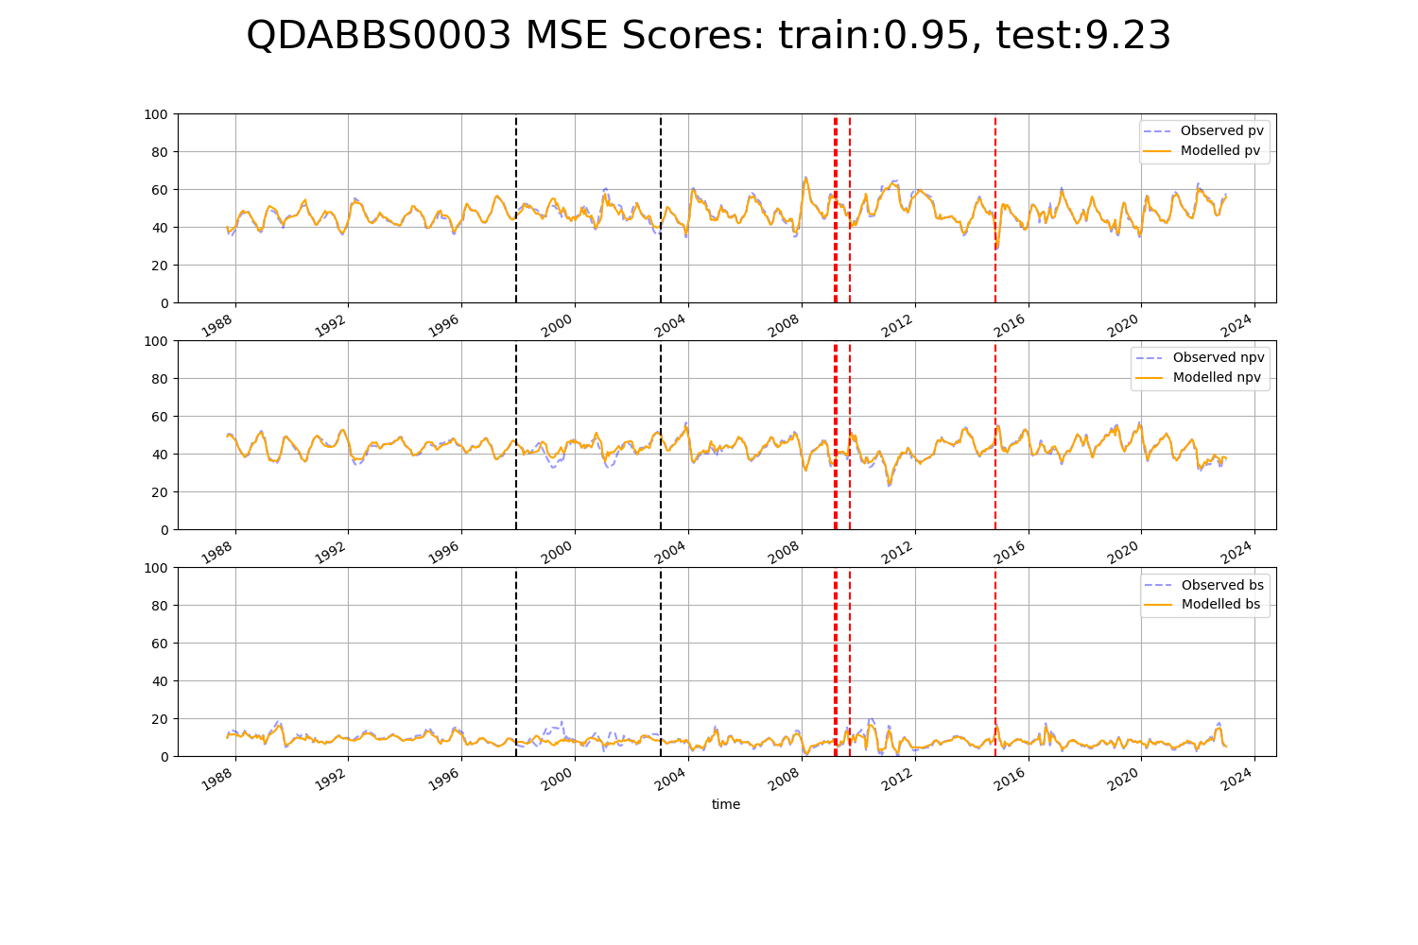

# QDABBS0005

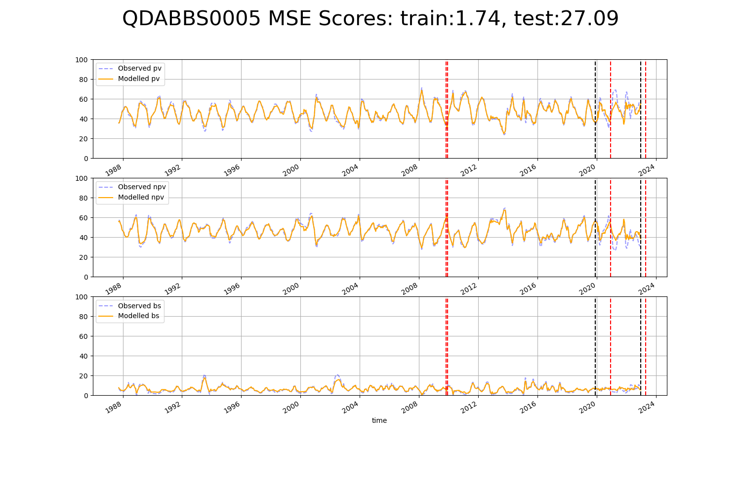

# QDABBS0009

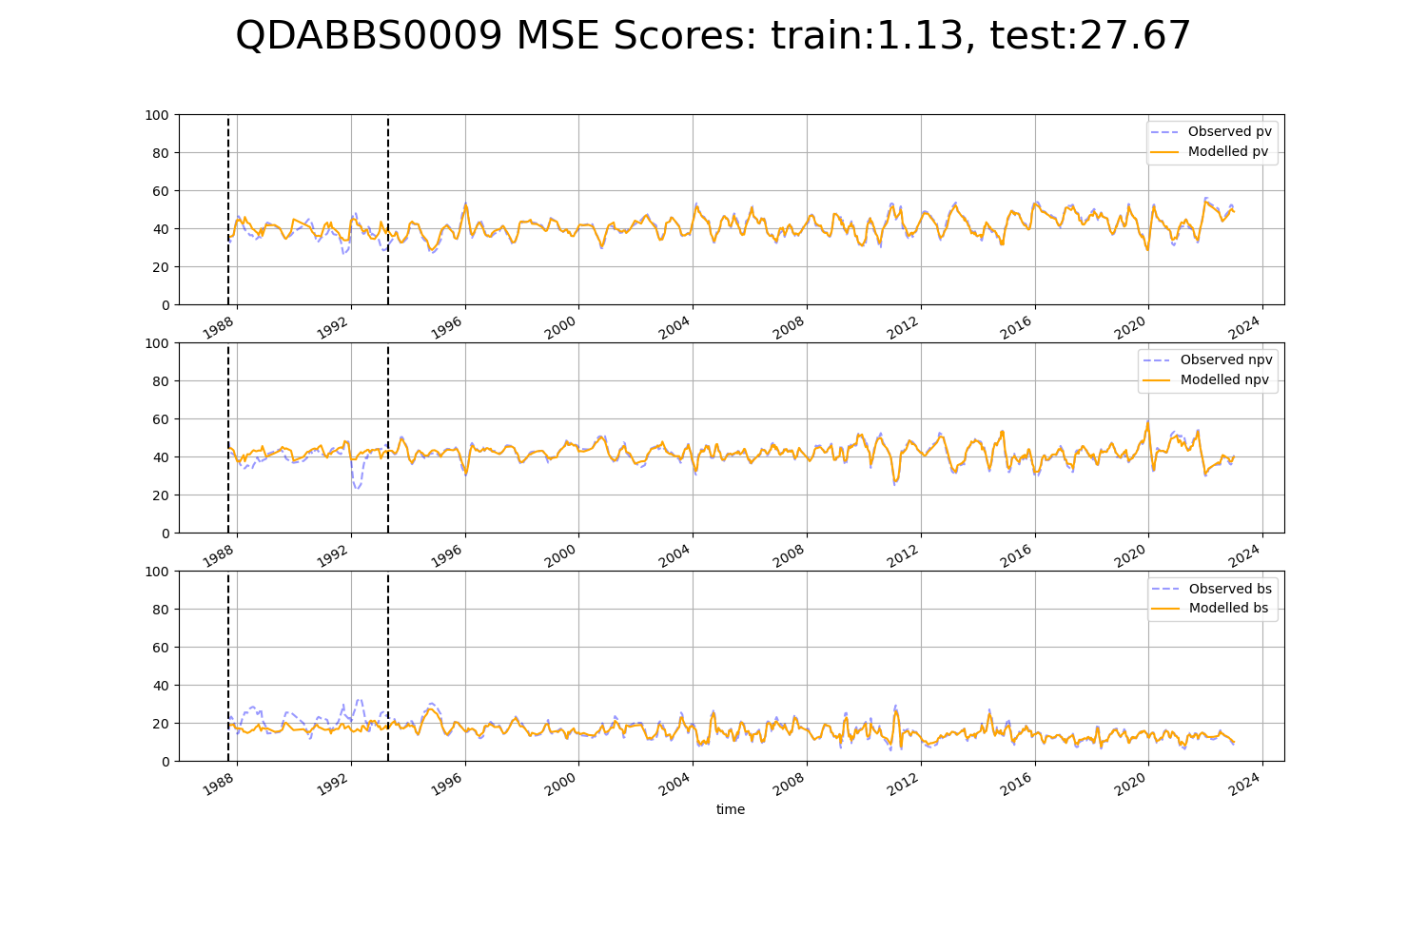

# QDACYP0008

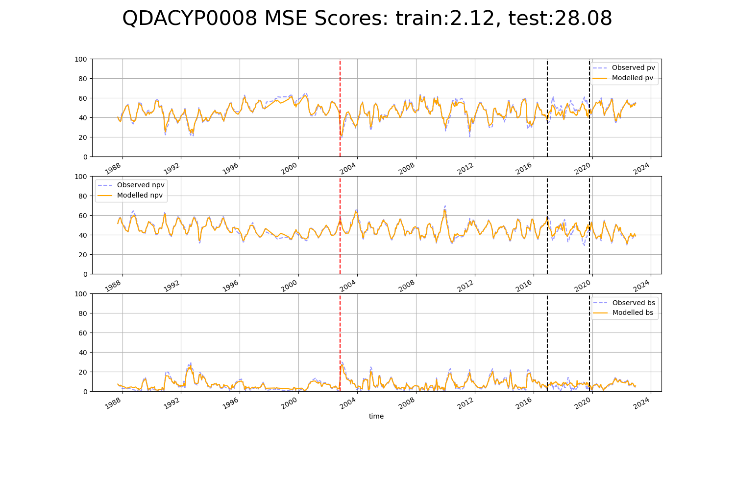

# QDACYP0012

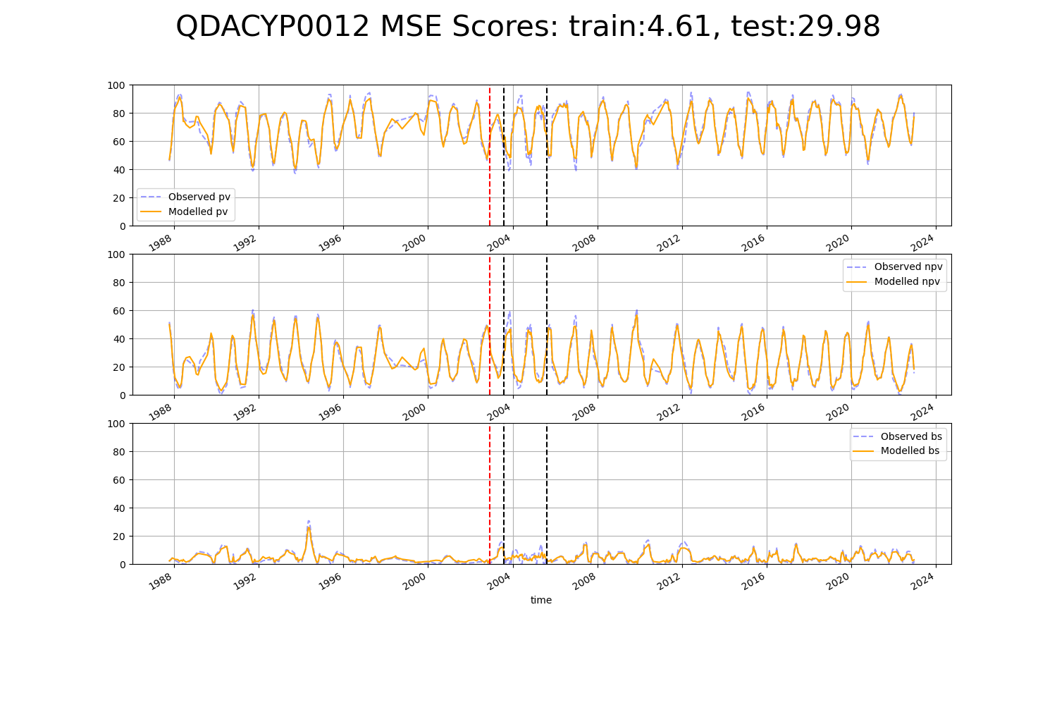

# QDACYP0016

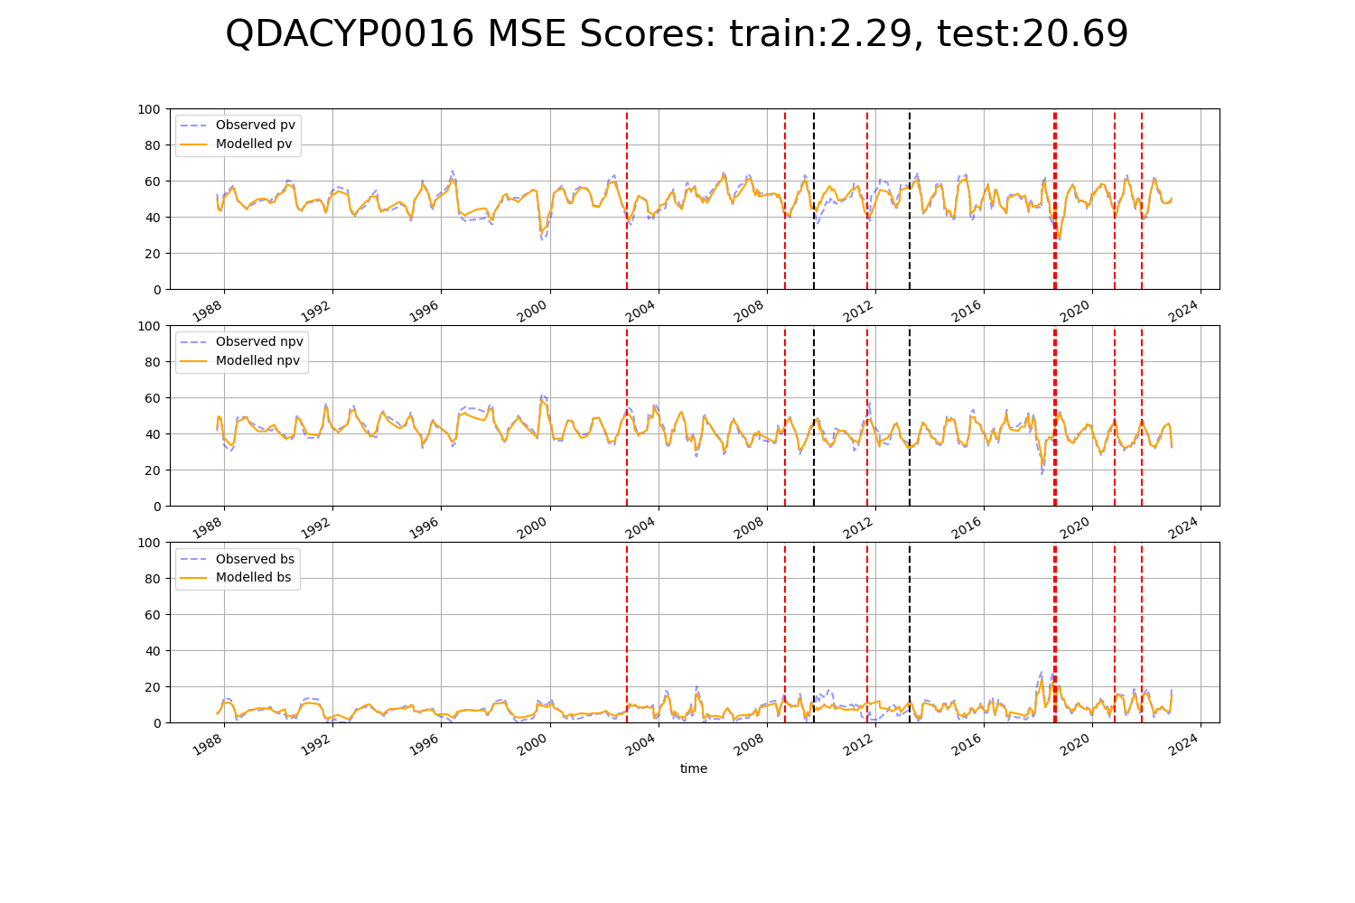

# QDACYP0020

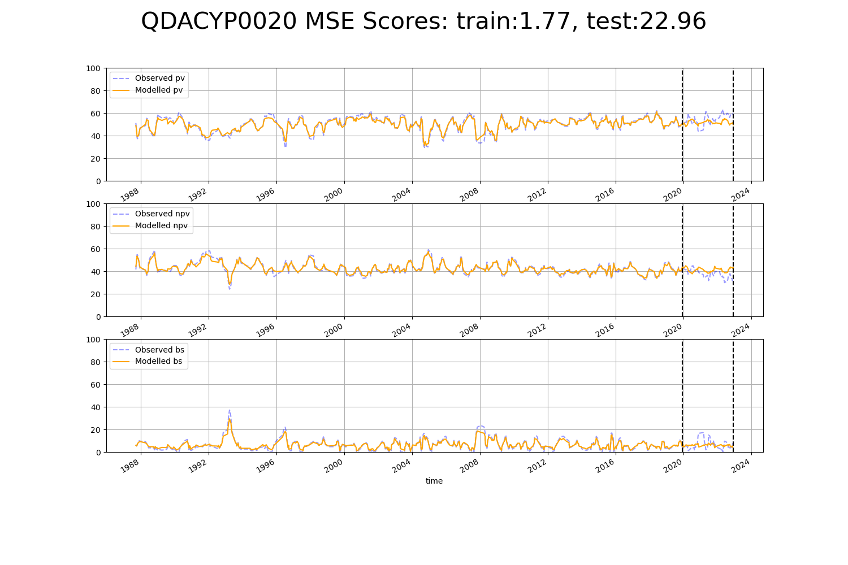

# QDACYP0021

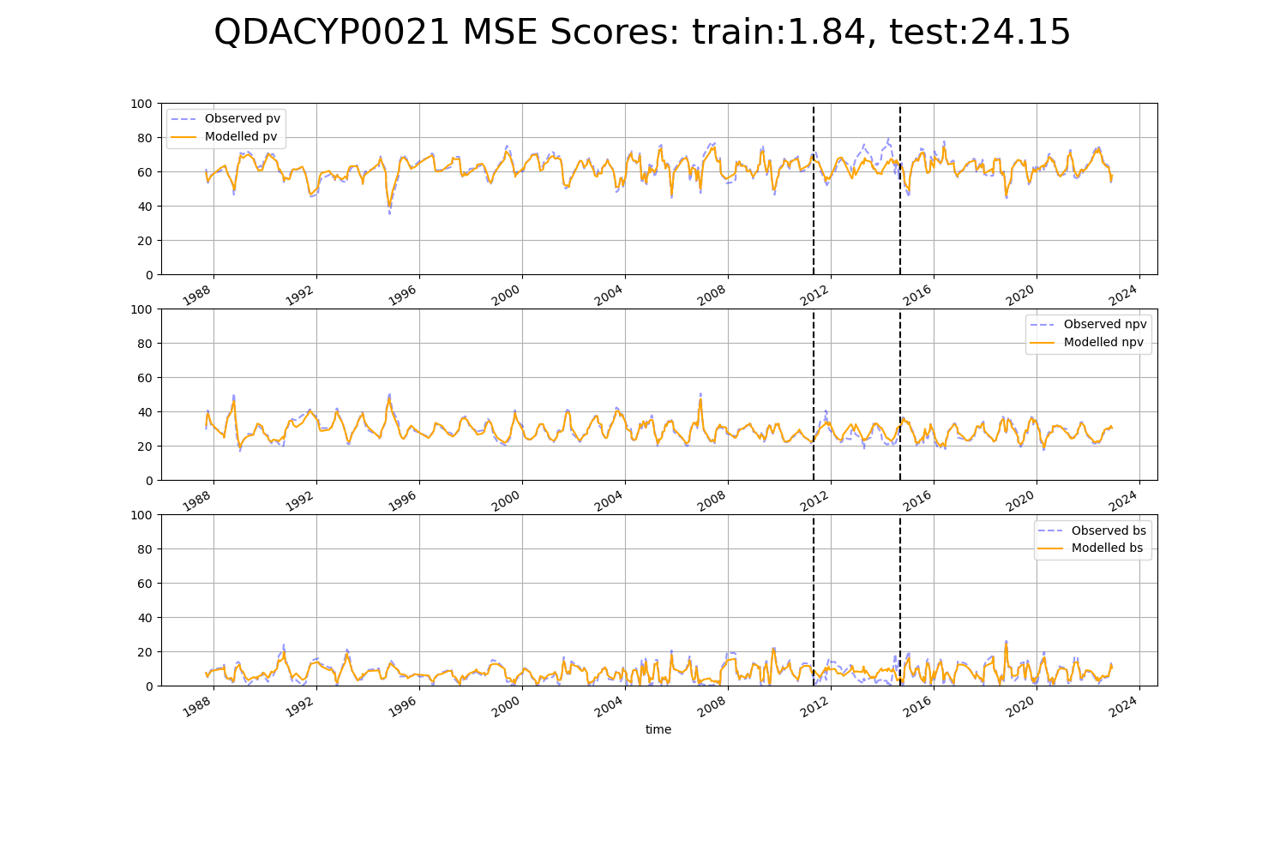

# QDACYP0024

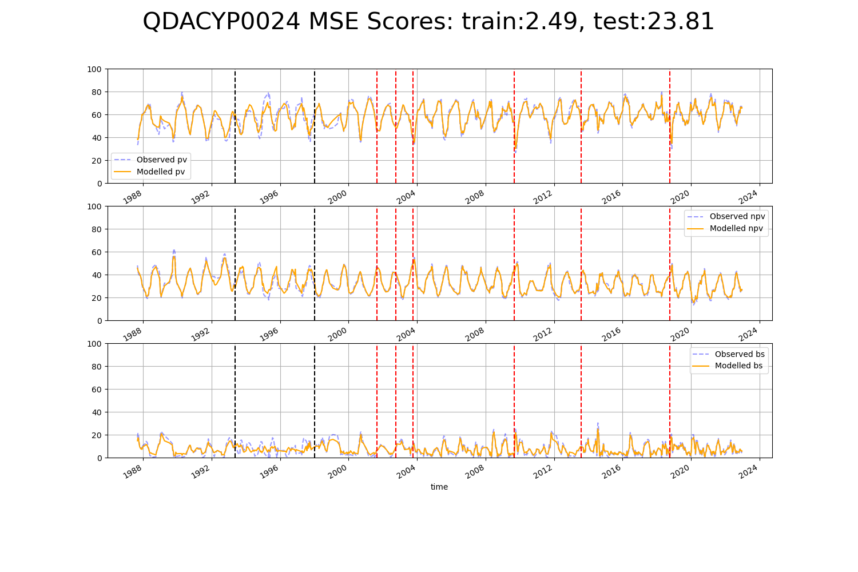

# QDAEIU0006

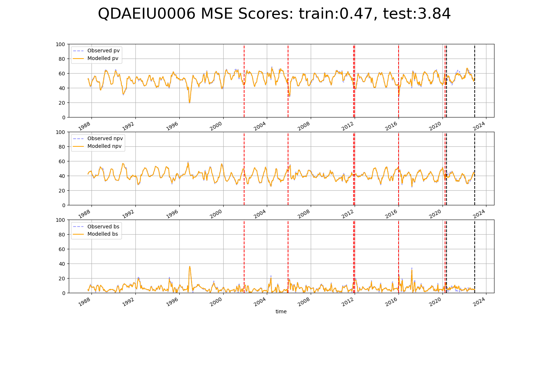

# QDAEIU0007

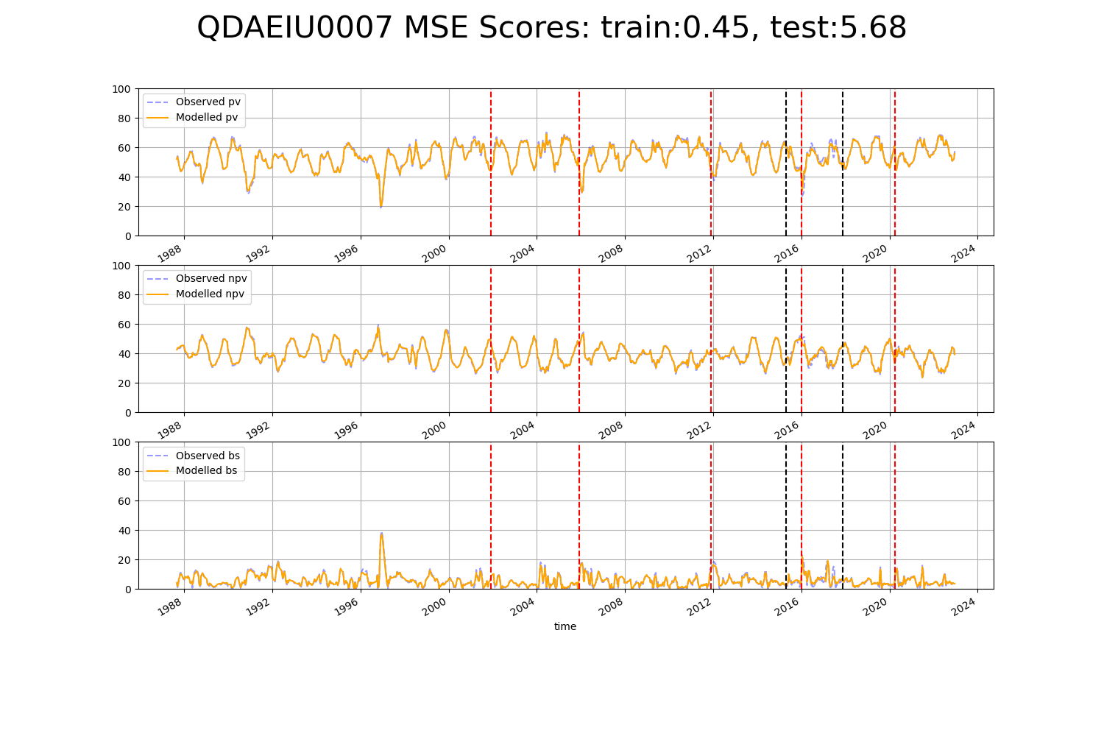

# QDAGUP0002

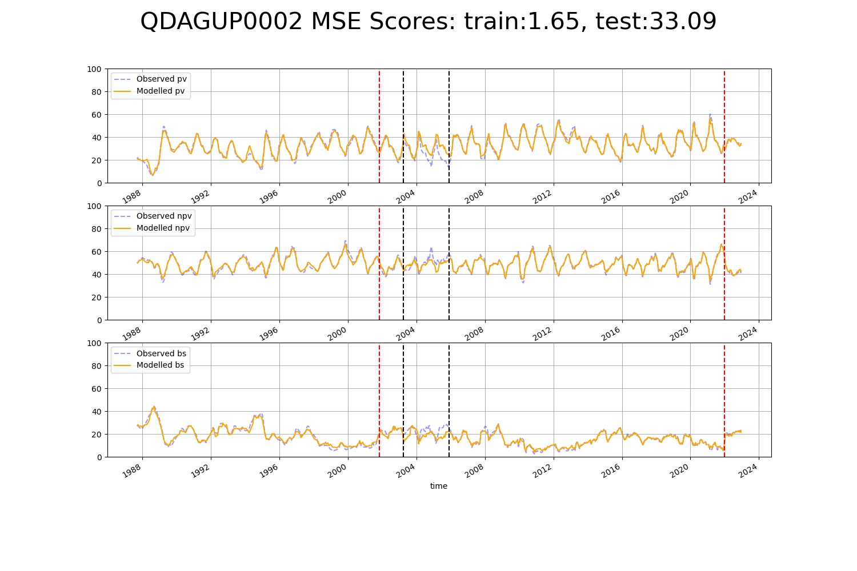

# QDAGUP0003

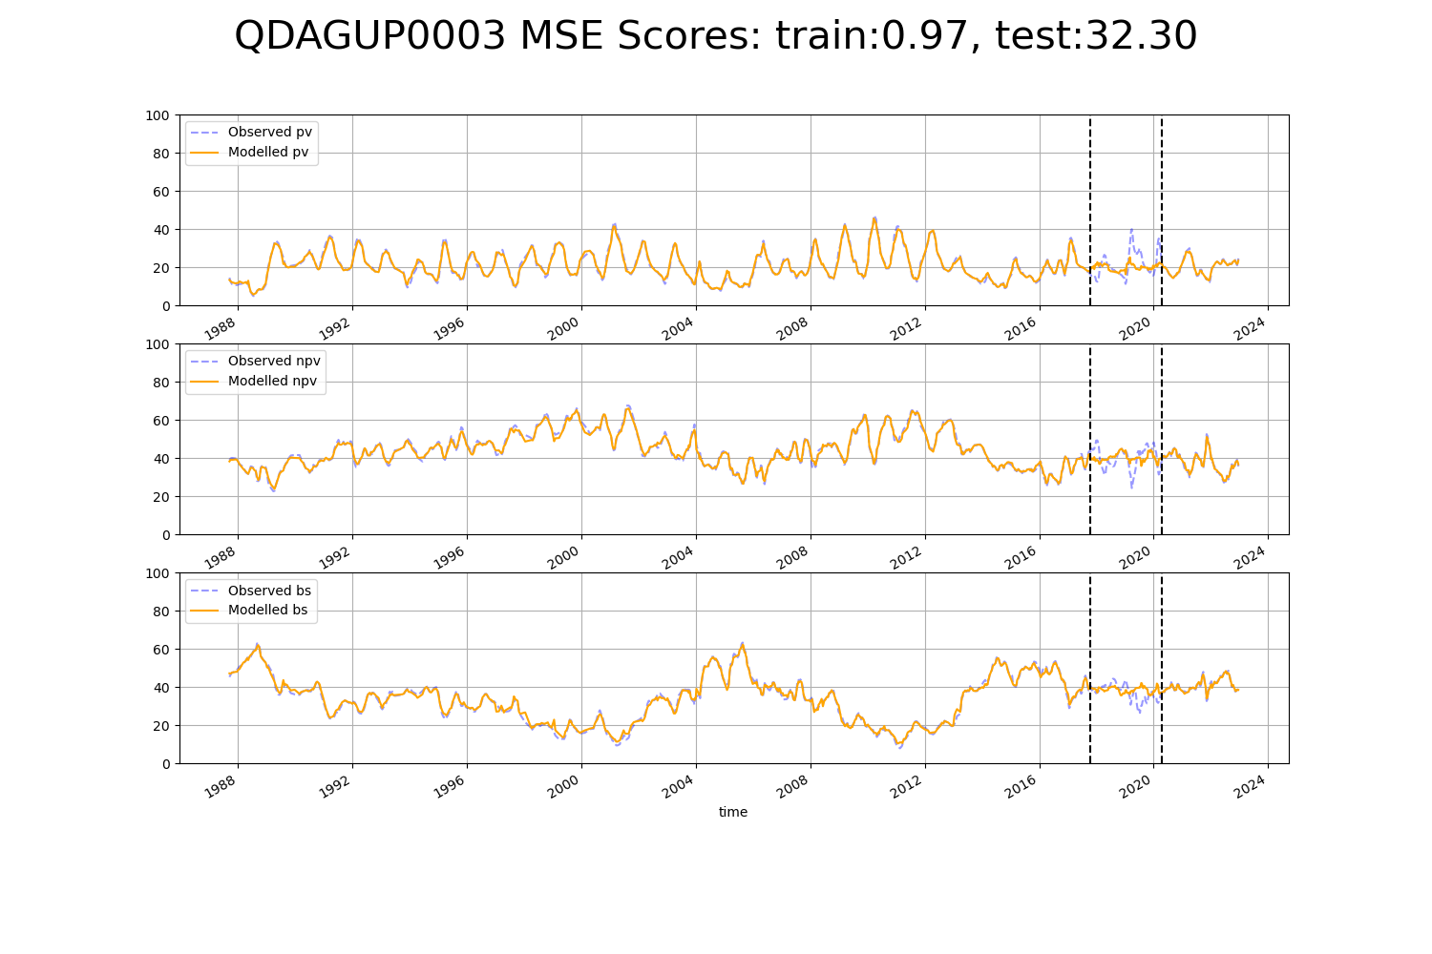

# QDAGUP0004

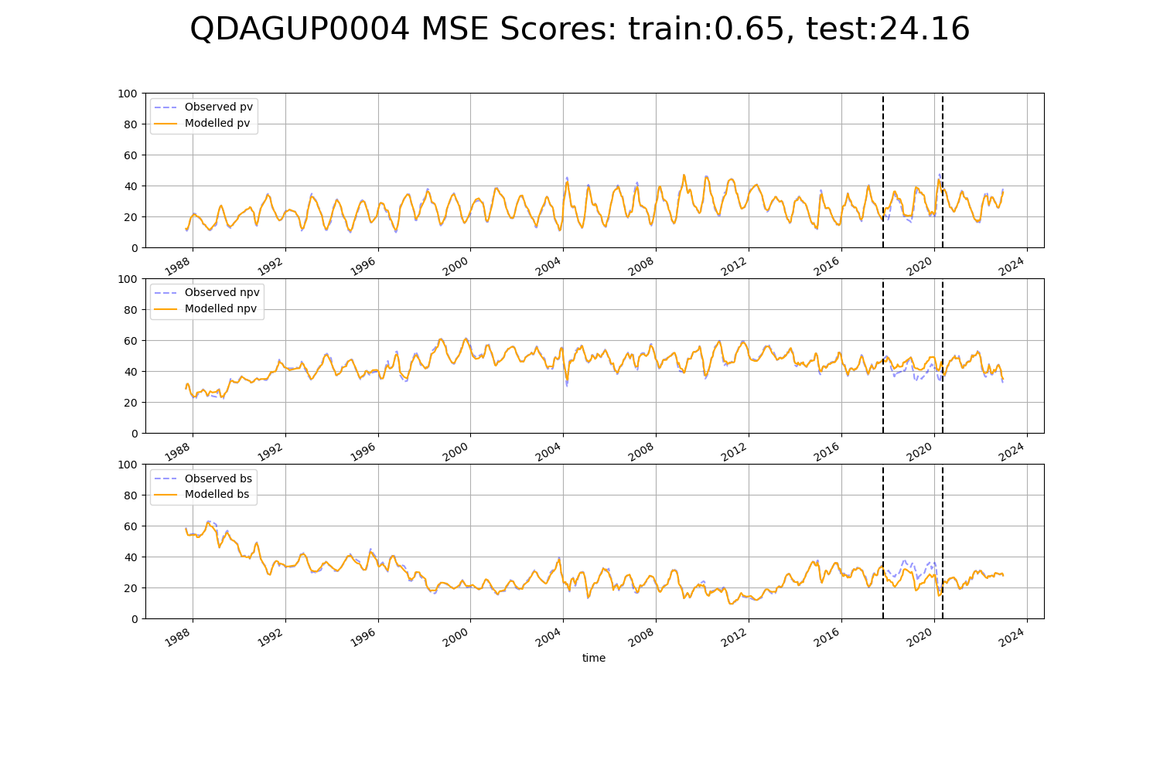

# QDAGUP0005

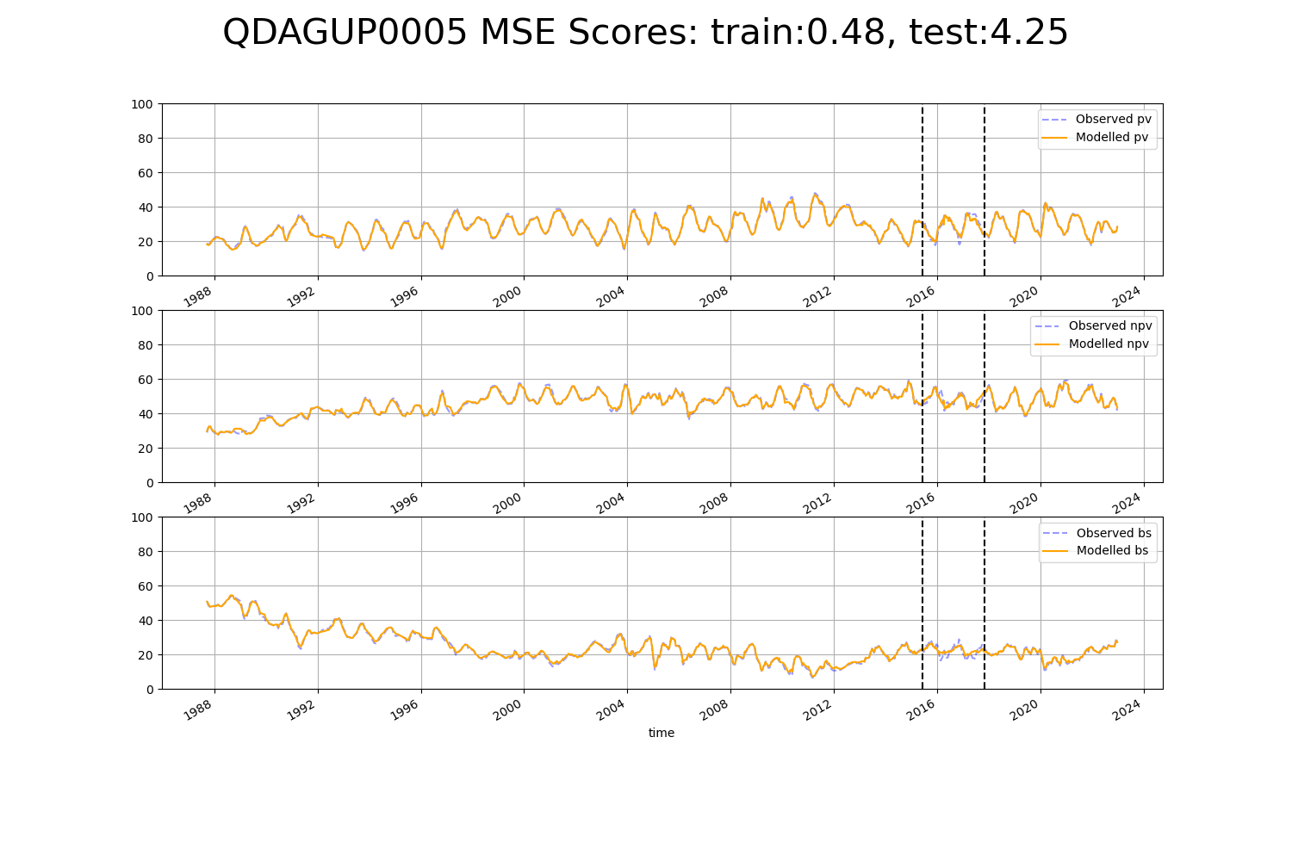

# QDAGUP0006

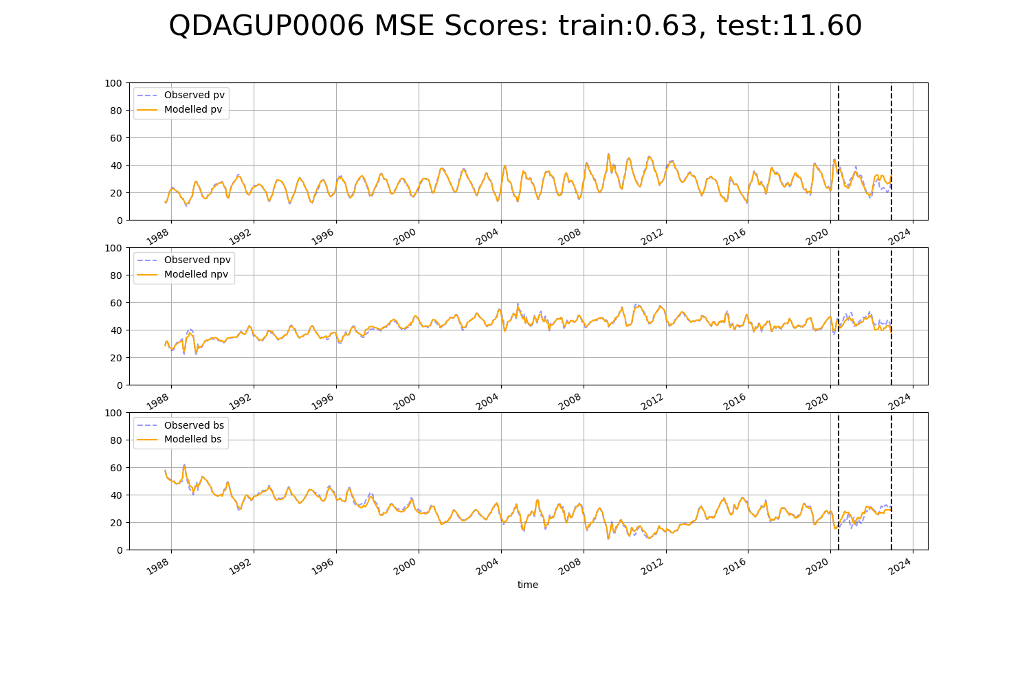

# QDAGUP0021

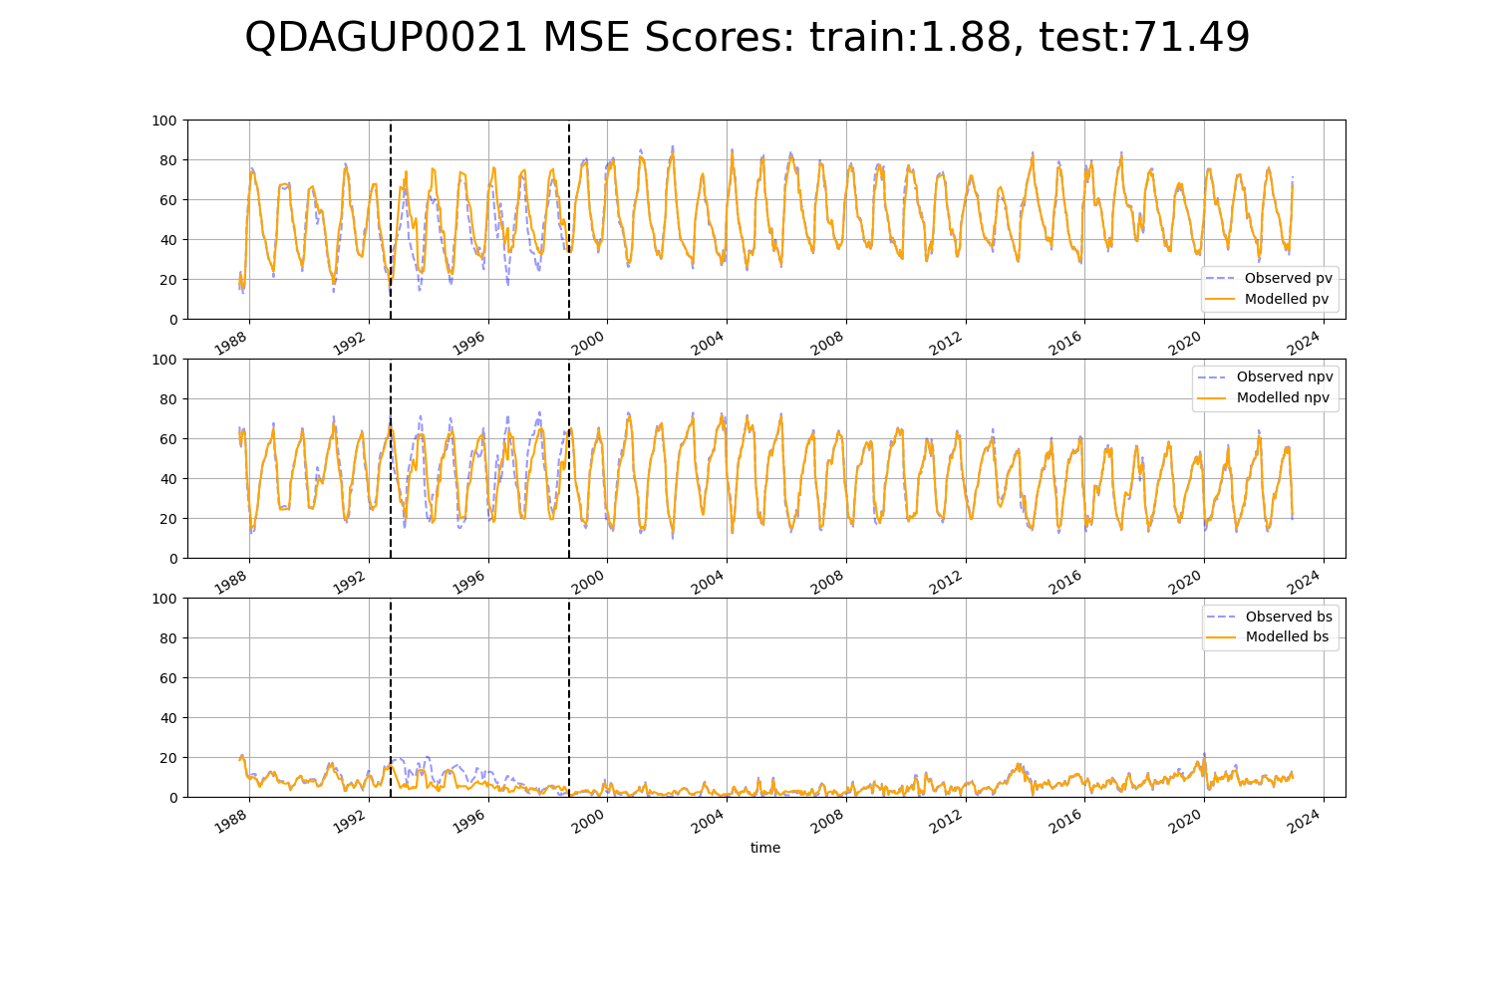

# QDAGUP0027

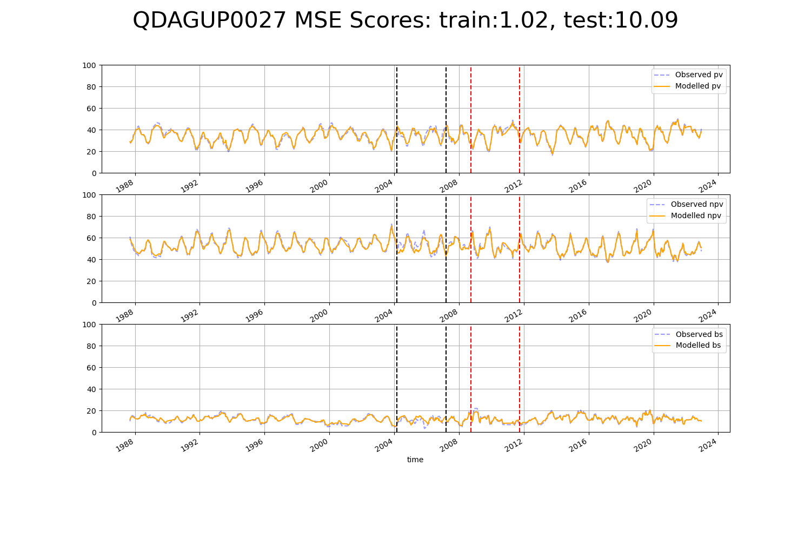

# QDAGUP0028

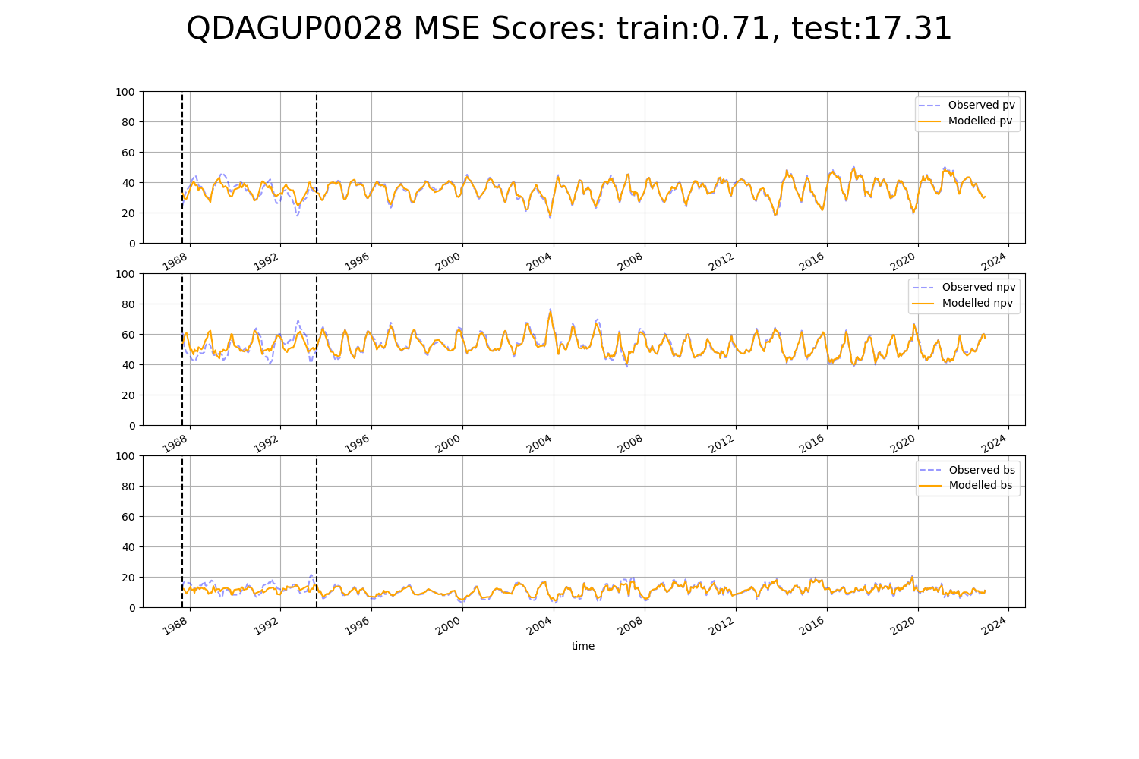

# QDAMGD0025

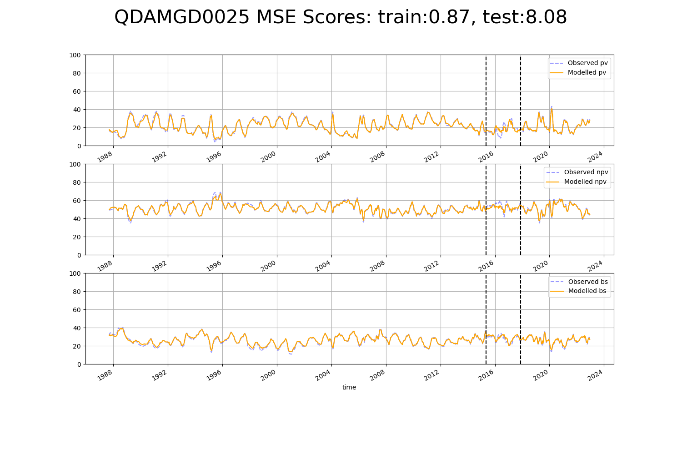

# QDAMGD0026

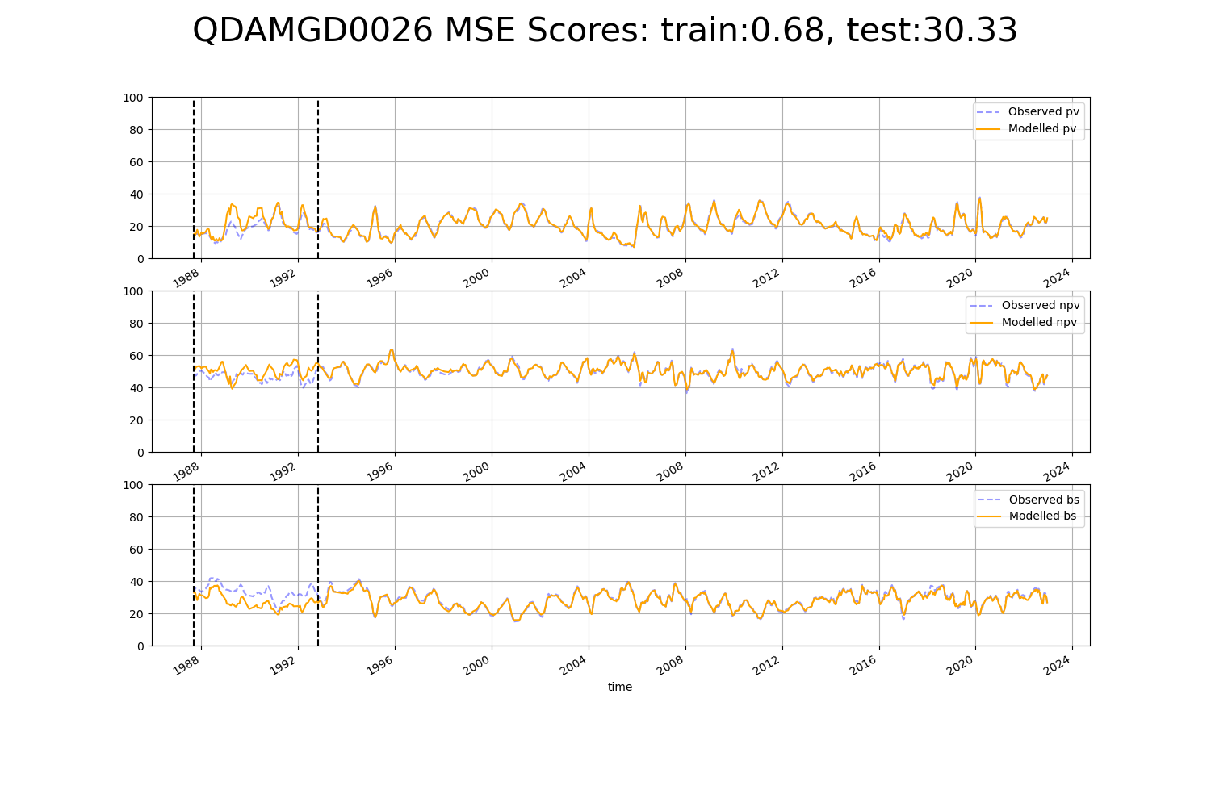

# WAACEK0001

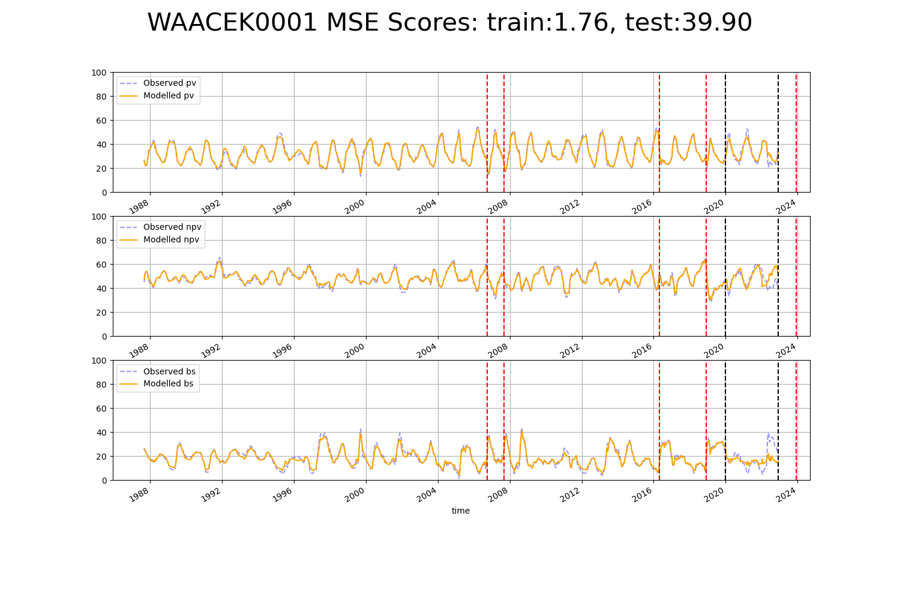

# WAADAL0004

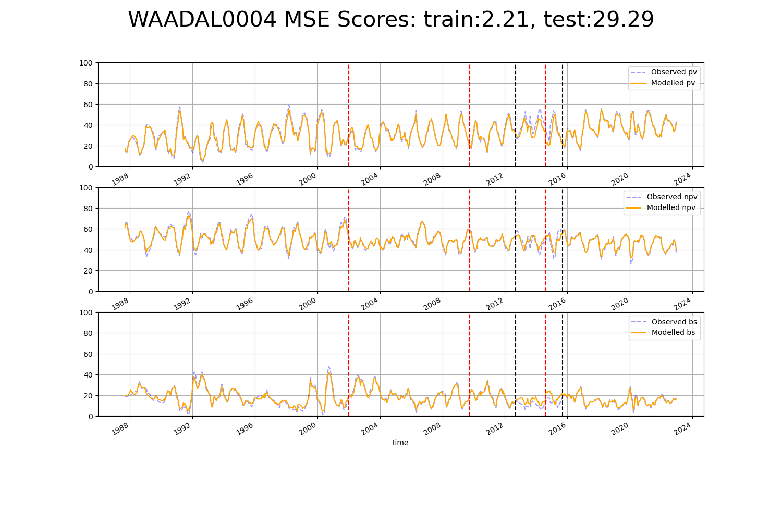

# WAANOK0001

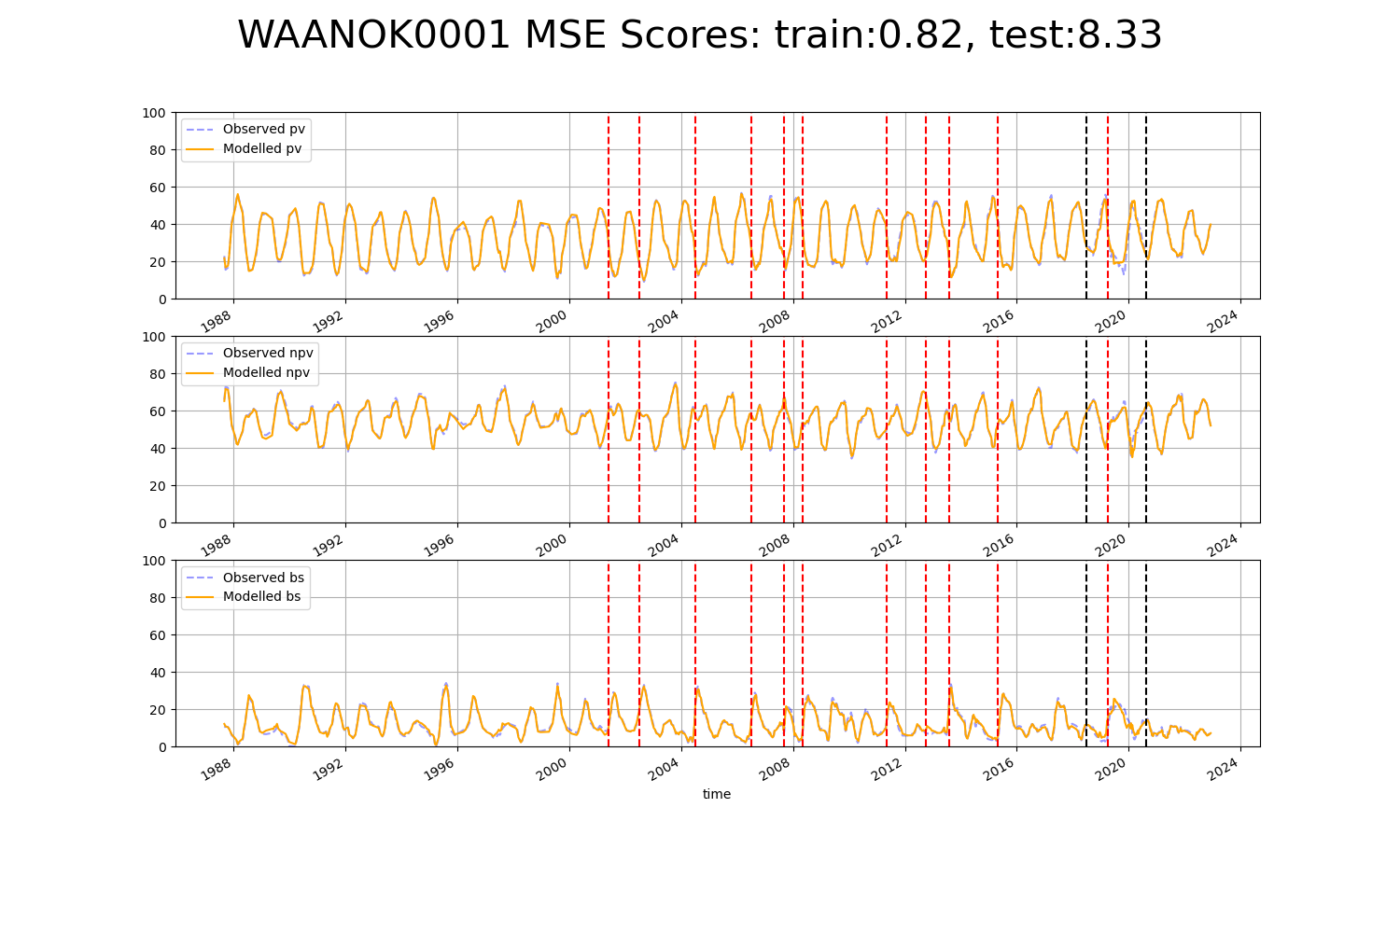

# WAANOK0002

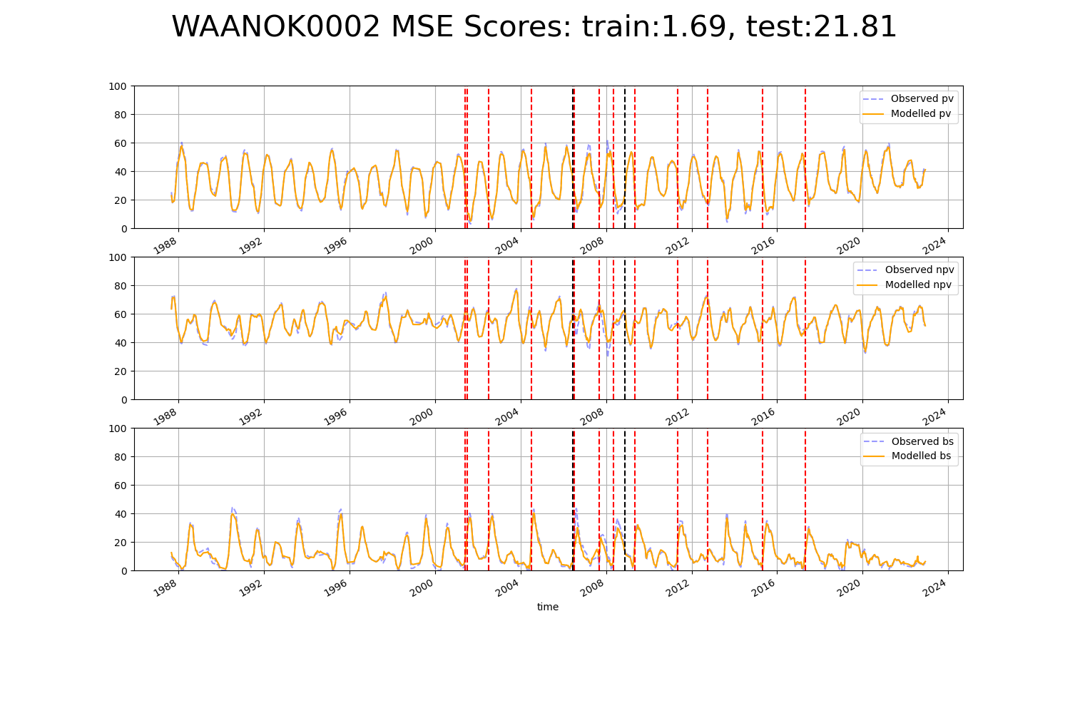

# WAANOK0006

